Brightspeed EASE LSR Job Aid
February 2018 Release (v1.4)

Version notice
History
All versions of this document are listed in reverse chronological order.

Version | Date | Description
1.4 | February 2018 | Updated Document to provide additional clarification to NOTES associated to the  AAI field (pages 9, 54)
1.3 | February 2018 | Updated Document to add Section: DLI Response Codes/Response Descriptions
1.2 | January 2018 | Updated Document to add Section: LSR Confirmation – Change to ORD field behavior
1.1 | November 2017 | Final Document
1.0 | August 2017 | Initial Document Creation
Important: This document has been through a formal review process. To the best of our knowledge, it is accurate. Brightspeed Communications, Inc. reserves the right
to make further modifications when necessary.

Table of Contents
Overview 3
LSR Pre-Order 3
Log In 3
EASE Address Validation Inquiry (TXTYP = A) 4
EASE Telephone Number Inquiry (TXACT = B) 15
Telephone Number Inquiry TXACT = A (New Inquiry) TNTYPE = N (New random number) 18
Telephone Number Inquiry TXACT = A (New Inquiry) TNTYPE = D (Specific number) 22
Telephone Number Inquiry TXACT = A (New Inquiry) TNTYPE = S (Sequential numbers) 25
Telephone Number Inquiry TXACT = A (New Inquiry) TNTYPE = R (Range of numbers) 28
Telephone Number Inquiry TXACT = K (Cancels selection or reservation) 32
EASE Customer Service Information Inquiry (CSI) (TXTYP = E) 35
EASE Loop Qualification (Loop Qual) Inquiry (TXTYPE = H) 40
Loop Qualification Inquiry with MS = A (Resale) by Address 43
Loop Qualification Results with MS = A (Resale) by Address 45
Loop Qualification Inquiry with MS = A (Resale) by WTN 46
Loop Qualification Results with MS = A (Resale) by WTN 47
EASE Raw Loop Data (RLD) Inquiry (TXTYPE=R) 49
Raw Loop Data Inquiry by TN 56
Raw Loop Data Inquiry by Assigned Address 59
Raw Loop Data Inquiry by Circuit 66
EASE Listings for Telphone Number Inquiry or DLI Directory Listing Inquiry (TXTYP = T) 68
Changes and/or Additions 71
Upgrade from LSOG 10 to LSOG 2Q14 71
Auto-populate pre-order validated addresses into the LSR 71
Auto-populate reserved Telephone Number(s) (TN) into the LSR 74
New Shipping Address section added to the End User (EU) form 76
Addition of Account Number to the Virtual Front Office (VFO) Order List Excel output 78
Prevent duplicate LSRs for same Working Telephone Number (WTN) 78
Versioning of Notices 79
LSR Confirmation – Change to ORD field behavior 81
DLI Response Codes/Response Descriptions 82

Overview
The Brightspeed EASE LSR 1Q18 Release Job Aid indicates what is changing from current EASE LSR Pre-Order functionality Version LSOG10 and provides information associated to the introduction of new EASE LSR functionality during the first quarter of 2018.

The online EASE Local Service Request VFO Preorder Guide will be updated to incorporate the changes and additions identified in this Job Aid prior to the deployment of this functionality.

LSR Pre-Order

Log In
To access the Pre-Order functionality, log into EASE using your established credentials at https://ease.brightspeed.com/.

Upon successful log in, select the PREORDER Tab from the menu bar. The options available are New (to create new Pre-Order transactions) and Search (to review previously saved Pre-Order transactions).

Pre-Order transactions supported in EASE LSR are:

A= Address Validation (existing functionality)
B = Telephone Number Inquiry (new functionality)
E = Customer Service Information (existing functionality)
H = Loop Qualification (new functionality)
R = Raw Loop Data (new functionality)
T = Listings for Telepone Number (DLI/Directory Listing Inquiry) (existing functionality)

PreOrder Initiation screen
New pre-order functionalities have been added to the existing dropdown.
TX Type:
A = Address Validation
B = Telephone Number Inquiry
C = Feature/Service Availability
D = Appointment Scheduling
E = Customer Service Information
H = Loop Qualification
K = Validate CFA
O = Facility Availability
R = Raw Loop Data
T = Listings for Telephone
W = Meet Point Query
X = View DLR

EASE Address Validation Inquiry (TXTYP = A)
The following detail will indicate what is changing from current Address Validation Inquiry functionality.

Address Validation provides new functionality that supports:
- Saving addresses for auto-population into the LSR or into the Pre-Orders of a Telephone Number Inquiry, Loop Qualification, or Raw Loop Data.
- Output displaying WTNs (Working Telephone Numbers), TN Status, Listed Name, Switch Indicator, and Switch Types.
Modifications to the previous functionality are identified in the following detail.

- Select New from the PREORDER Tab.

- To execute an Address Validation inquiry, complete the following fields:
  - TXNUM – The system will pre-populate this field with a numeric value. RECOMMENDATION: The user can override this information with the PON to be used during ordering to better track their inquiries. In essence, the PON becomes the Pre-order TXNUM.
  - Select TXTYP of A – Address Validation.
  - Select the Initiate button.

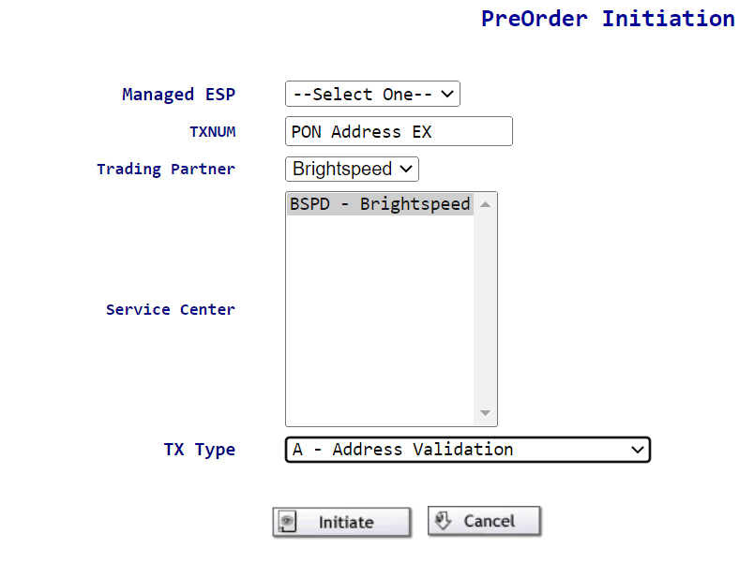

- An Address Validation screen will display.

Note that the TXNUM field displays the PON entry rather than the system generated TXNUM once that entry is overtyped.

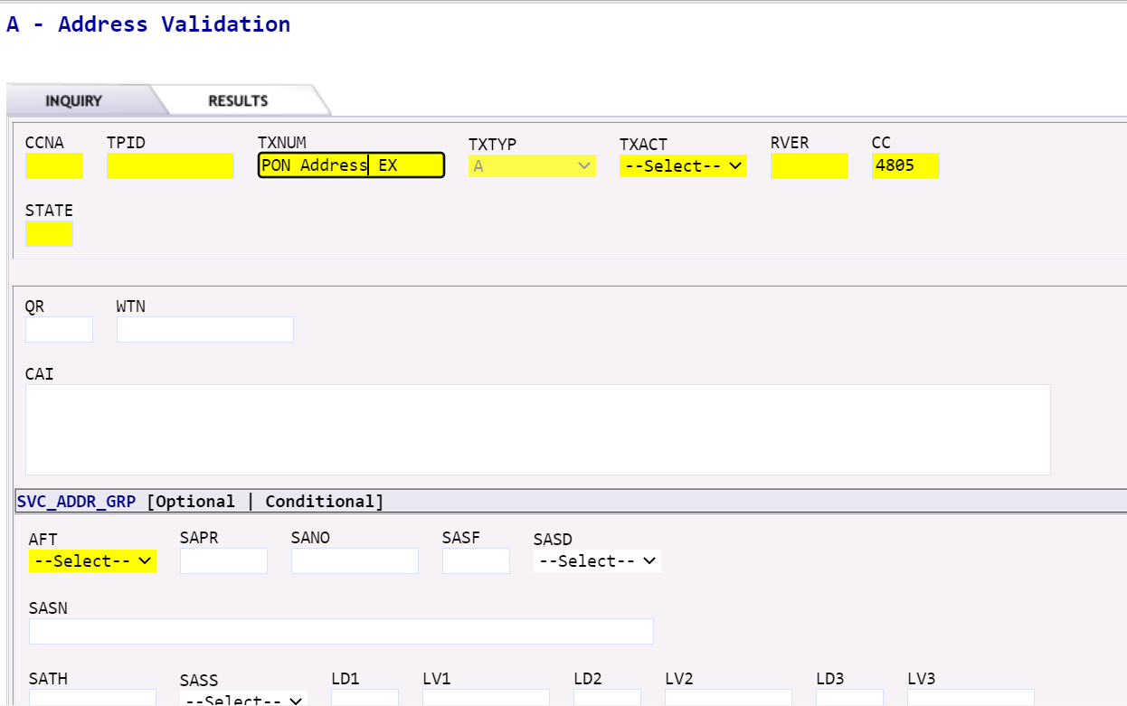

- Complete the following fields when creating an Address Validation query by TN.
  - TXACT - Select A = New inquiry.

NOTE: This is the only option for Address Validation. If not entered, EASE defaults to this value and processes the request.

  - STATE – Enter appropriate 2 digit state code in upper case.
  - If querying by Working TN, enter detail in the WTN field.
    - WTN identifies the working telephone number associated with the address validation inquiry and includes NPA, NXX, and 4 digit line number – Example: NPANXXXXXX.

Or

  - If querying by Address, enter detail in the SVC ADDR GRP.

Minimum Address field entries are:
- SANO identifies the number of the service address.
- SASN identifies the street name of the service address.
- SATH identifies the thoroughfare portion of the service address, such as LN (lane) or BLVD (boulevard).
- CITY identifies the city, village, or township.
- STATE identifies the abbreviation for the state or province.
- ZIP identifies the ZIP or postal code.
  - Submit

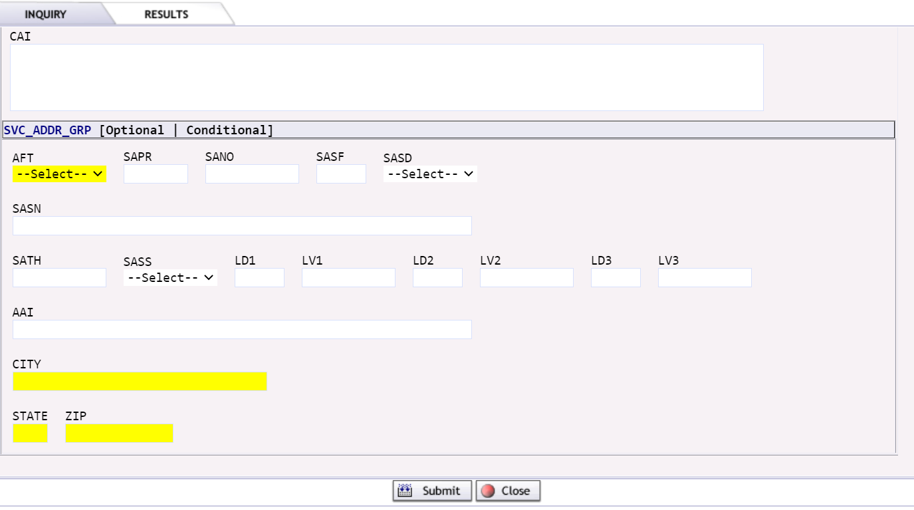

NOTE: Additional Address Detail fields may be populated if they apply to the inquiry address:
- SAPR identifies the prefix for the address number of the service address
- SASF identifies the suffix for the address number of the service address
- SASD identifies the street directional prefix for the service address. Valid entries:
  - E = East
  - W= West
  - N = North
  - S = South
  - NE = Northest
  - NW = Northwest
  - SE = Southeast
  - SW = Southwest
- SASS identifies the street directional suffix for the service address. Valid entries are shown below.
  - E = East
  - W= West
  - N = North
  - S = South
  - NE = Northest
  - NW = Northwest
  - SE = Southeast
  - SW = Southwest
- LD1, LD2, LD3 identifies additional specific information related to the address. Valid entries:
  - LD1
    - APT
    - LOT
    - RM/ROOM
    - SLIP
    - UNT/UNIT
    - STE/SUIT
  - LD2
    - FL/FLR
  - LD3
    - BLDG
    - WNG
    - PIER
- LV1, LV2, LV3 identifies the value associated with the location designator.
- AAI identifies additional location information about the address.

NOTE: Previously, the AAI field was required to be populated if there is additional detail specific to the address such as room, apartment, suite, floor, etc.

With this implementation, supplemental address information may be entered in either the LD/LV or the AAI fields. EASE will accept input in either and send the data downstream.

Supplemental data can be entered in any LD/LV fields. Entries are not specific to LD1 vs. LD2 vs. LD3 at this time.

LD/LV fields edit for USPS data content like UNIT. The AAI field edits for MARTENS data content like UNT.

Presently, supplemental data for complex addresses will be returned in the AAI fields.

Saved addresses with supplemental data will prepopulate in the AAI field but can be changed and typed in individual LD/LV fields.

AAI Input:

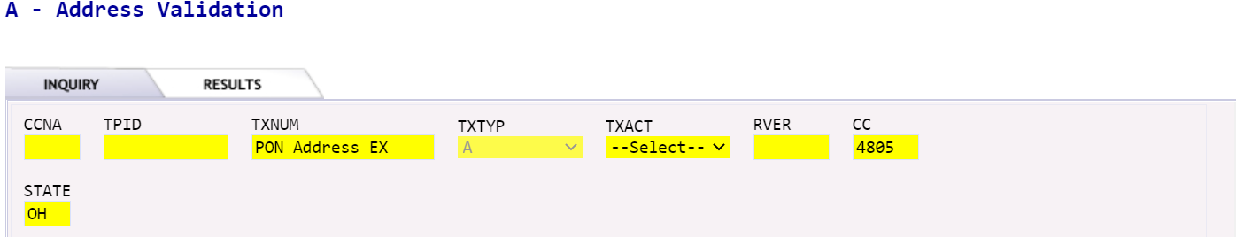

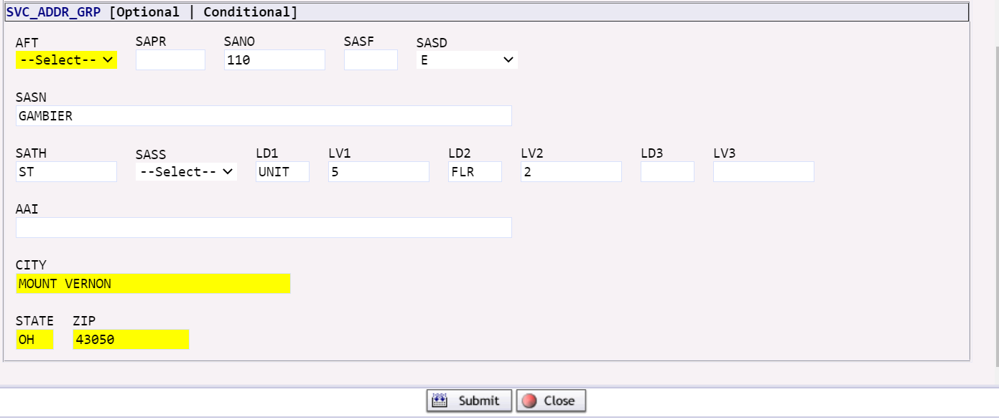

AAI Output:

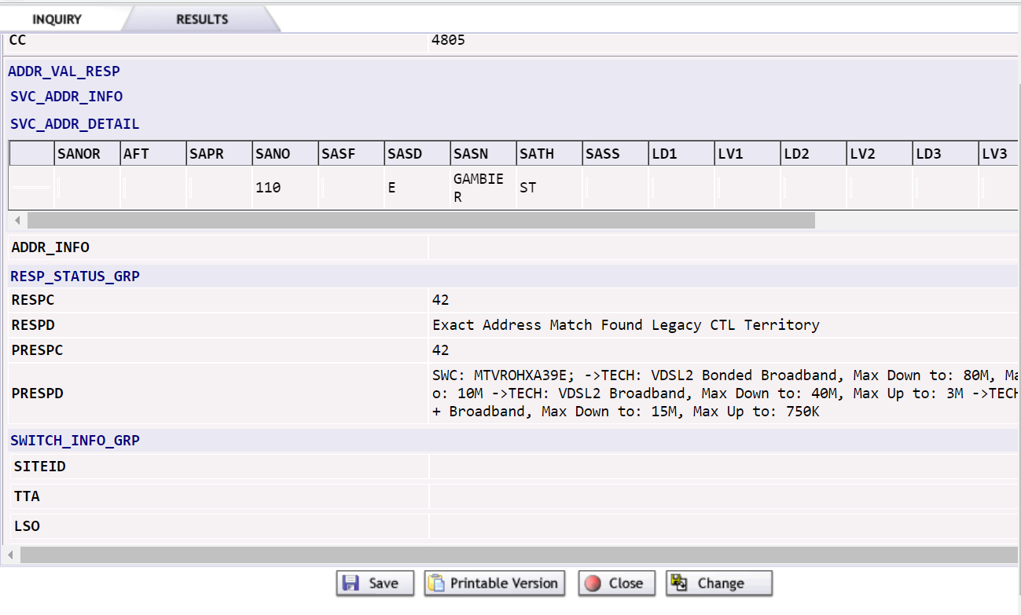

Based on the information entered on the Address Validation Inquiry tab, the system will execute the request and provide a response upon submission.

The Location response results will display in the RESPD field:
  - Exact Address Match Found – The WTN or address information entered was executed successfully and an exact match for the data entered was found.

  - Address Near Match Found/Alternatives Provided – There are multiple addresses that meet the criteria entered. The user shall review alternatives displayed for the correct address, change the criteria, and resubmit the inquiry.

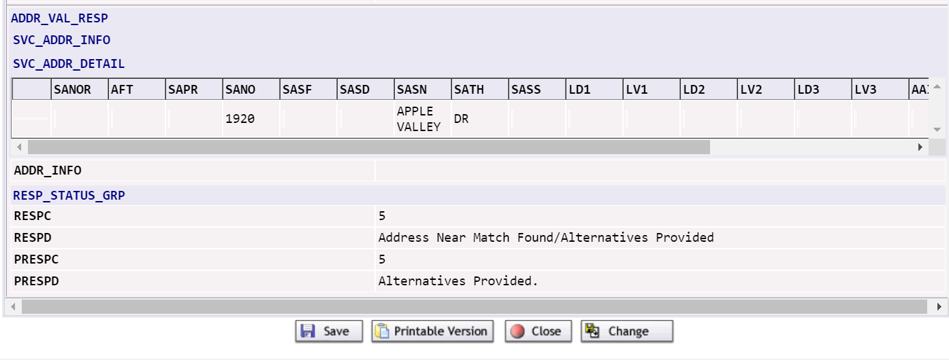

  - Address Not Found - There were no addresses that met the criteria entered.

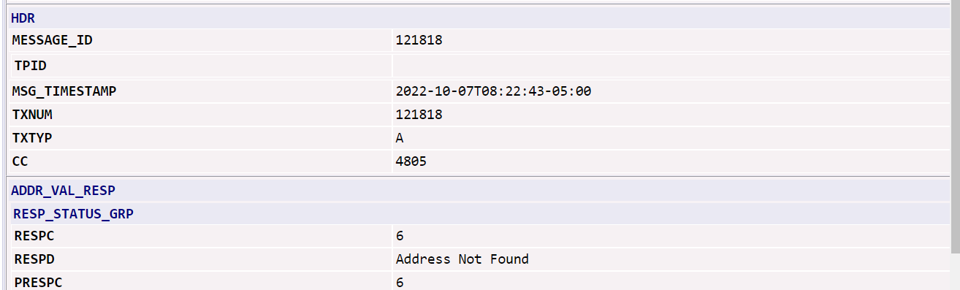

  - User is able to Save / Print / Close / Change the inquiry. In order to return to the address pre-order inquiry screen and modify the data, click on Change.

EASE Telephone Number Inquiry (TXACT = B)
This Pre-Order function replaces the TN Assignment accessed through the External App Data for TN Assignment on the LSR Order Menu option on the Order List page.

TNs may be requested for the following:
- New Service
- A new line on existing service
- Change of a telephone number

EASE offers you several options for requesting TNs:
- Select one or more of the TNs offered for auto-population into the LSR
- Exchange the TNs offered
- Reject the TNs offered

A TN Reservation can be executed within EASE for LSR Pre-Order and also within EASE for LSR Ordering.

- Select New from the PREORDER Tab.

- To execute an Telephone Number inquiry, complete the following fields on the PreOrder Initiation screen:
  - TXNUM – The system will pre-populate this field with a numeric value.

RECOMMENDATION: The user can override this information with the PON to be used during ordering to better track their inquiries.

  - TXTYP – Select B = Telephone Number Inquiry
  - Select the Initiate button.

- A new Telephone Number Inquiry screen will display.

Note that the TXNUM field displays the PON entry rather than the system generated TXNUM.

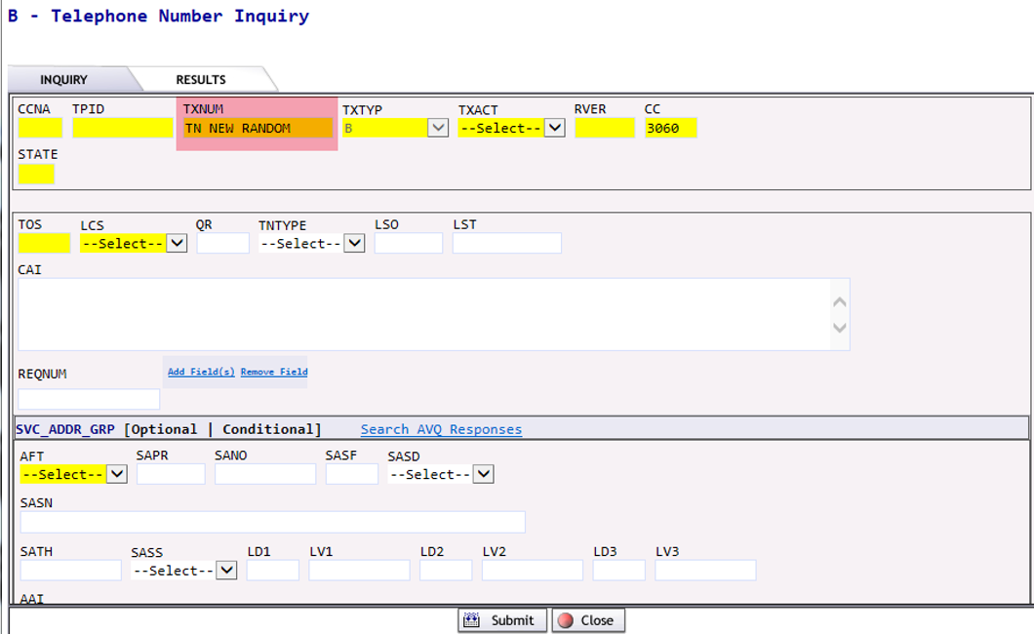

- Complete the following fields for an initial TN inquiry (TXACT = A).

NOTE: Directions for Selection, Reservation, and Cancellation (TXACT = K) will be provided later in this document.

  - TXACT - Select A = New inquiry
  - STATE – Enter appropriate 2 digit state code in upper case.
  - TOS – Enter appropriate 4 digit Type of Service Code.
  - LCS – Enter the Local Calling Scope. (Optional)
Default is A = Local Service

NOTE: This field will be addressed in more detail on a future implementation.

  - QR – Enter the quantity of numbers requested for this inquiry. (Optional)

NOTE: If no entry is provided, a default of ten telephone numbers or the number presently available, based on the input, are returned.
  - TNTYP – Select the appropriate entry from the pulldown:
    - D = Specific Numbers
    - N = New Random Number
    - R = Range of Numbers
    - S = Sequential Numbers

  - LSO – Enter a preferred NPA/NXX for the telephone number(s) requested. (Optional)

NOTE: This entry is normally used when an address is served by multiple NXXs. The customer may have a preference of one over another or in the case of working service, may want to match to an existing number.

  - REQNUM – Enter the telephone number(s), or range of telephone numbers requested. (Optional)

  - SVC ADDR GRP – Address detail can be optionally pre-populated from previously saved Address Validations.

NOTE: An example of this functionality is provided later in the Job Aid.

Minimum Address field entries are:
- SANO identifies the number of the service address.
- SASN identifies the street name of the service address.
- SATH identifies the thoroughfare portion of the service address, such as LN (lane) or BLVD (boulevard).
- CITY identifies the city, village, or township.
- STATE identifies the abbreviation for the state or province.
- ZIP identifies the ZIP or postal code.
- Additionally, there are optional fields like CCNA, TPID, RVER, etc. which may be populated.
- Submit.

Telephone Number Inquiry TXACT = A (New Inquiry) TNTYPE = N (New random number)

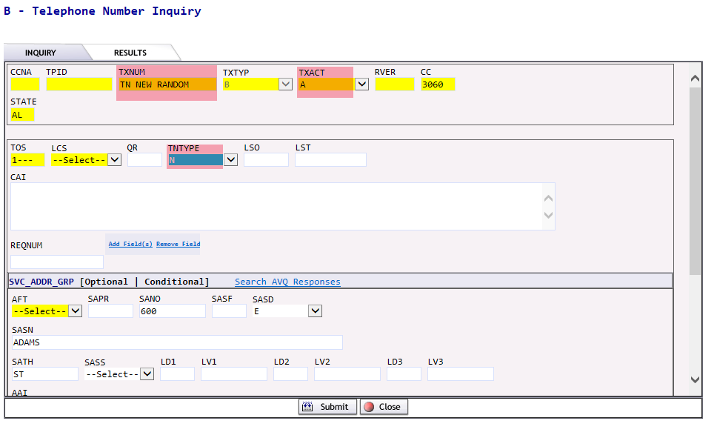

- Once a new inquiry has been processed, you may select from the telephone numbers displayed. A single number, a combination of numbers, or all numbers may be selected and ultimately reserved. If the numbers are not selected, they will be returned to the number pool. If the numbers are not reserved within 20 minutes, they will be returned to the number pool.

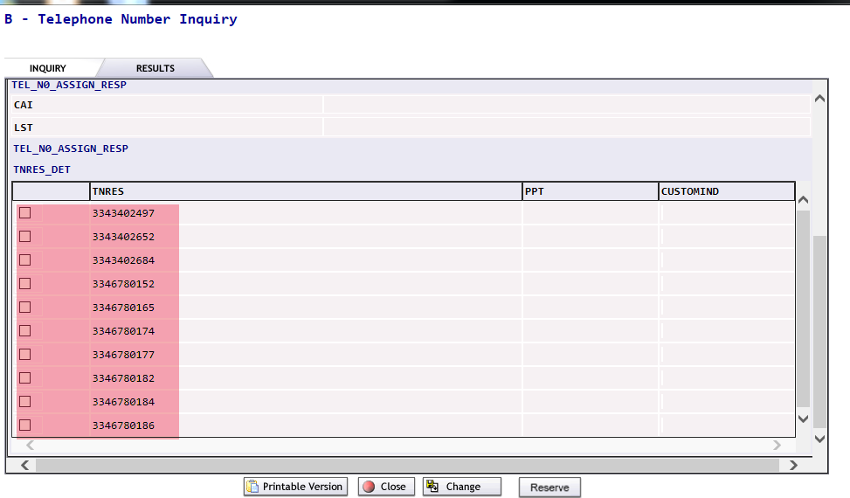

- Check the box associated with the number you wish to select.

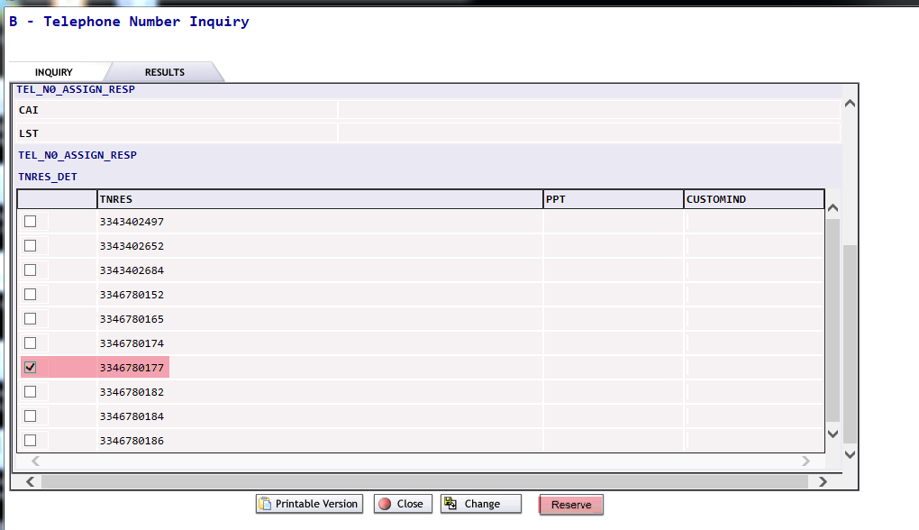

- Once the telephone number(s) has been selected, you may reserve the number(s) by choosing the Reserve button located under the list of displayed numbers on the bottom far right of the screen.

A message will display in the PRSPD field indicating the status of the reservation and number(s) reserved.

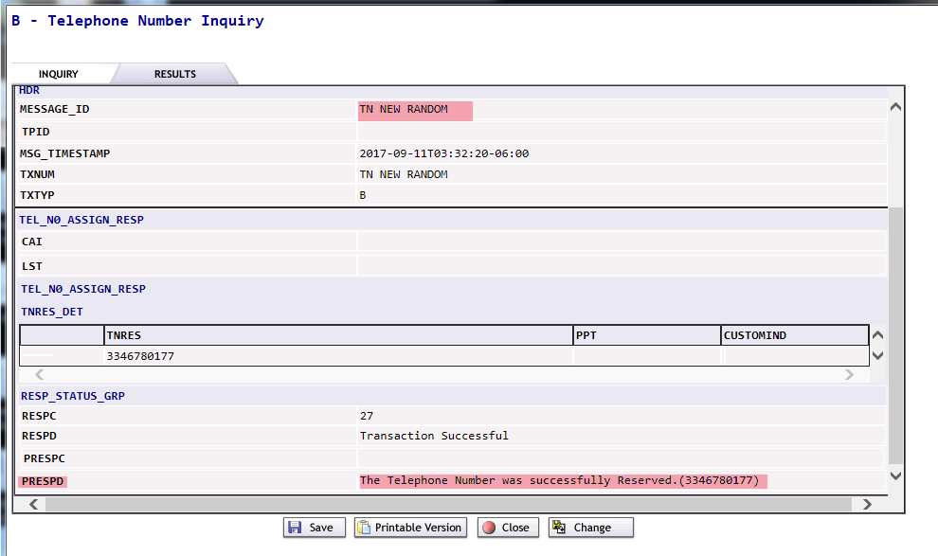

- The numbers are reserved against your PON entered in the TXNUM field.

- Save and Close.

Telephone Number Inquiry TXACT = A (New Inquiry) TNTYPE = D (Specific number)

NOTE: For a specific number(s), the TNTYPE field entry must be D and the REQNUM field entry must be populated with the Requested Number. Additional REQNUM fields can be added using the Add Field(s) link.

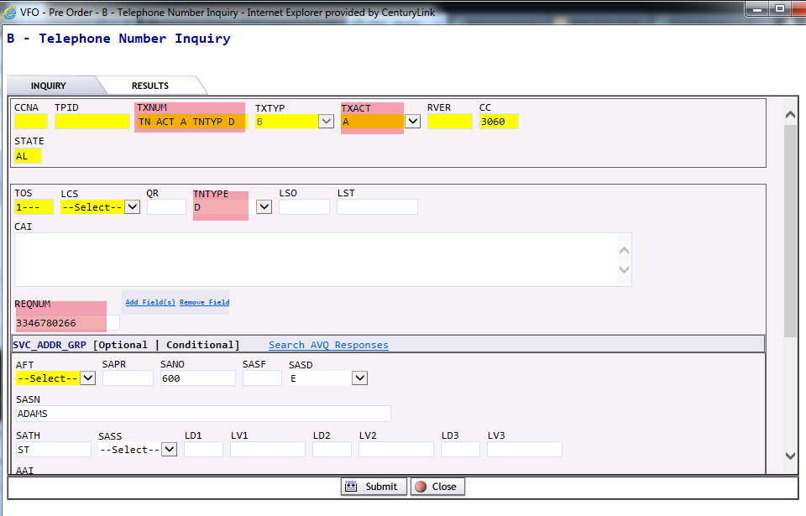

- Once the inquiry has been processed, you will receive a PRESPD message indicating that the Available Telephone Numbers were successfully retrieved for the given criteria. The numbers may be selected and reserved. If the numbers are not selected, they will be returned to the number pool. If the numbers are not reserved within 20 minutes, they will be returned to the number pool.

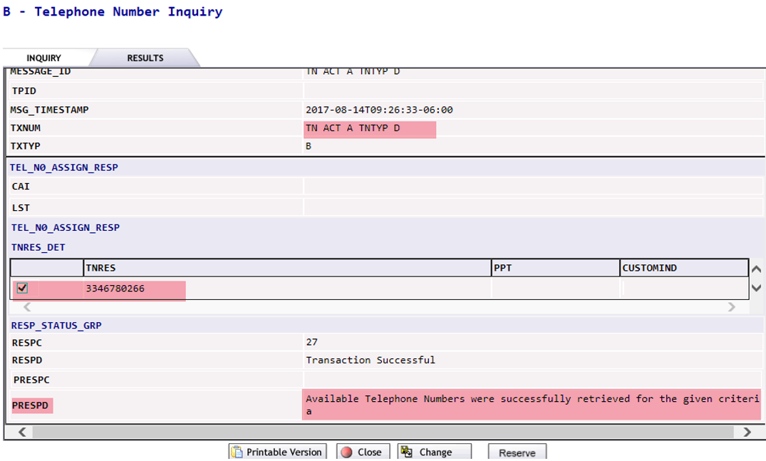

- If the specific number requested is not available, you will receive a PRESPD message indicating that Requested Telephone Number NOT Available, returning others Available (xxxxxxxxxx).
- Check the box associated to the number(s) you wish to select.
- Once the telephone number(s) has been selected, you may reserve the number(s) by choosing the Reserve button located under the list of displayed numbers on the bottom far right of the screen.
- The numbers are reserved against your PON entered in the TXNUM field.
- If the numbers are not selected, they will be returned to the number pool. If the numbers are not reserved within 20 minutes, they will be returned to the number pool.
- Close.

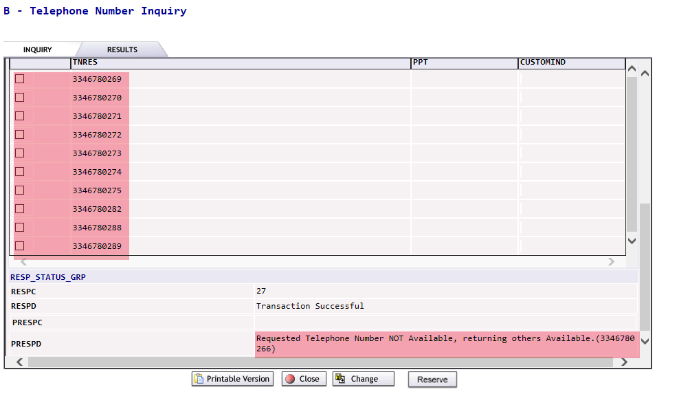

Telephone Number Inquiry TXACT = A (New Inquiry) TNTYPE = S (Sequential numbers)

NOTE: For sequential number(s), the TNTYPE field entry must be S and the QR field entry must be populated with a maximum of 5 which is the default.

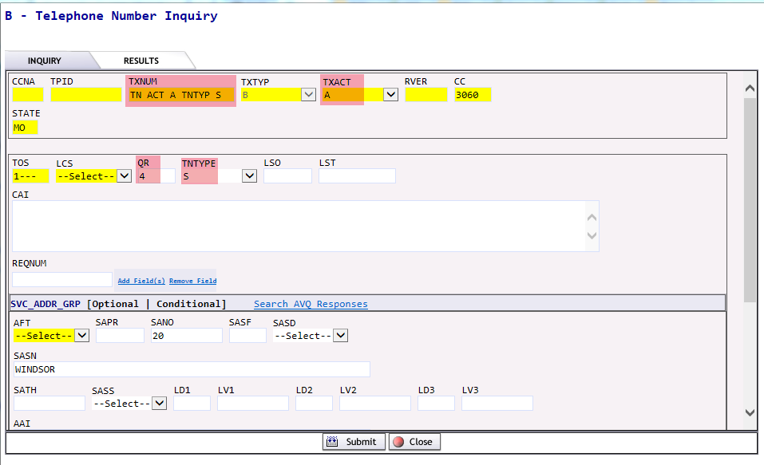

- Once a new inquiry has been processed, you may select from the telephone numbers displayed. Any sequential numbers based on the QR entered may be selected and ultimately reserved. If the numbers are not selected, they will be returned to the number pool. If the numbers are not reserved within 20 minutes, they will be returned to the number pool.

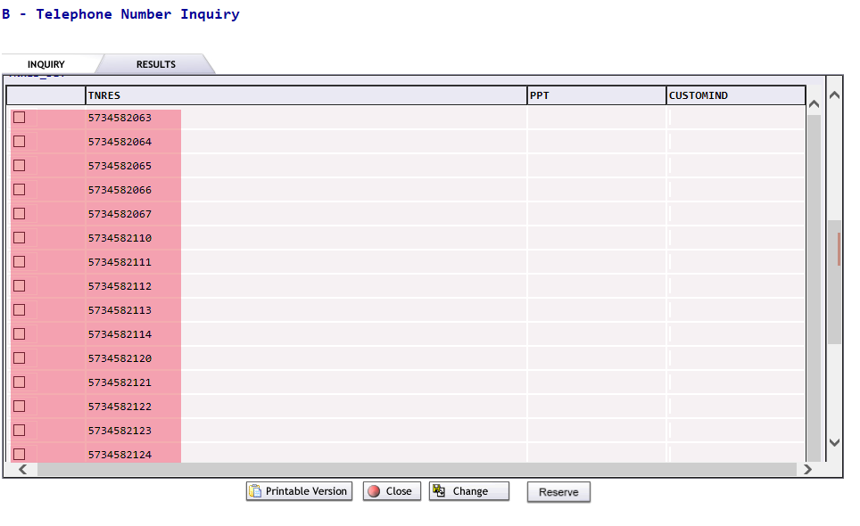

- Check the boxes associated with the numbers you wish to select.
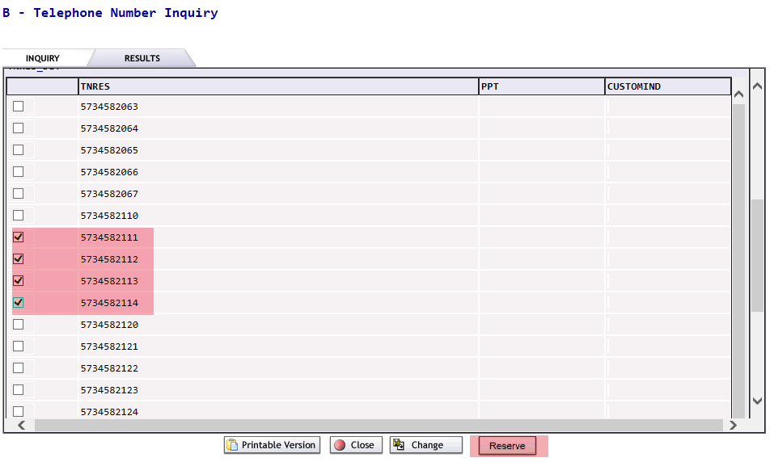
- Once the numbers are selected and reserved, you will receive a PRESPD message indicating the telephone numbers were successfully reserved. The reserved numbers will display in the TNRES column of the TNRES Detail section.

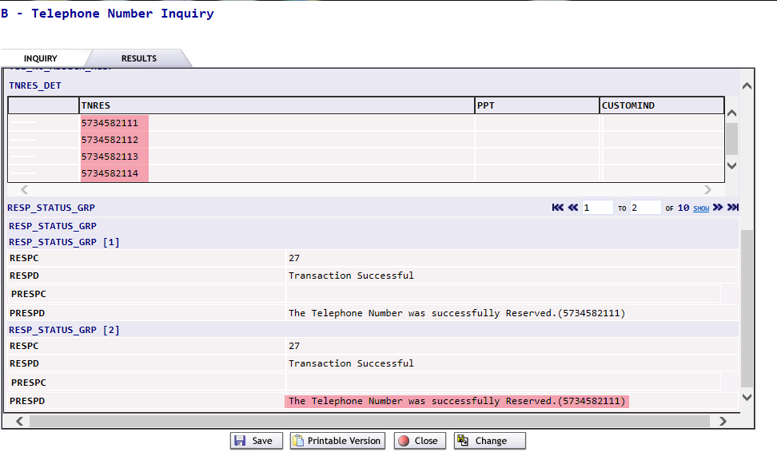

Telephone Number Inquiry TXACT = A (New Inquiry) TNTYPE = R (Range of numbers)

NOTE: For a range of number(s), the TNTYPE field entry must be R, the QR field entry must be populated with a maximum of 10 which is the default, the specific range must be populated in the REQNUM field.

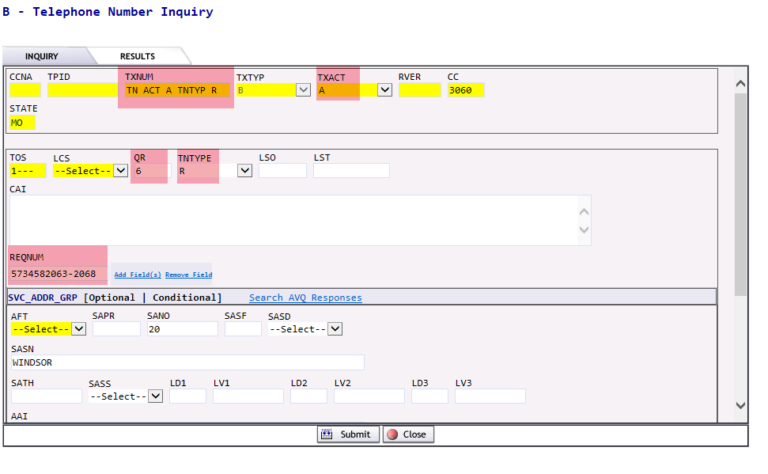

- Once a new inquiry has been processed, you may select from the telephone numbers displayed. Any sequential numbers based on the QR entered may be selected and ultimately reserved. If the numbers are not selected, they will be returned to the number pool. If the numbers are not reserved within 20 minutes, they will be returned to the number pool.

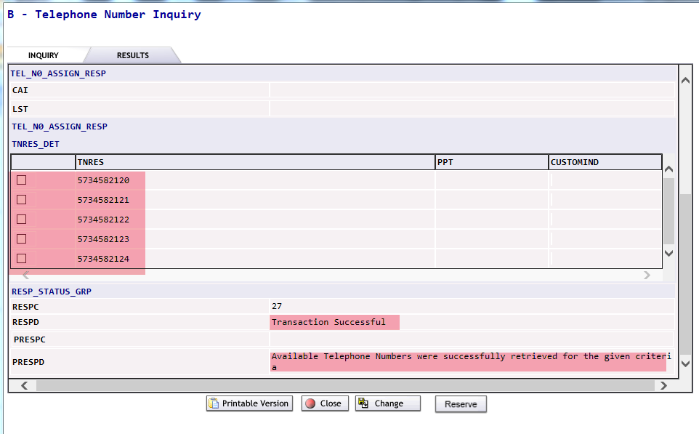

- Check the boxes associated with the numbers you wish to select.
- Once the numbers are selected and reserved, you will receive a PRESPD message indicating the telephone numbers were successfully reserved. The reserved numbers will display in the TNRES column of the TNRES Detail section.

If you have a need to cancel previously reserved telephone numbers:
- Select New from the PREORDER Tab.
- A PreOrder Initiation screen will display. To execute a Telephone Number cancellation, complete the following fields:
  - TXNUM – The system will pre-populate this field with a numeric value.

NOTE: For a cancellaton, the user cannot override this system generated TXNUM with the PON used during the original TN Reservation Pre-order. The system generated TXNUM or a new TXNUM meaningful to the user can be entered.

  - TXTYP – Select B = Telephone Number Inquiry.
- Select the Initiate button.
- A new Telephone Number Inquiry screen will display.
- Complete the following fields.
  - TXACT – Select K = Cancels selection or reservation.
  - SELNUM (Selected Number/Reserved Number)

NOTE: You need to verify this is the TN you want to cancel.

Telephone Number Inquiry TXACT = K (Cancels selection or reservation)

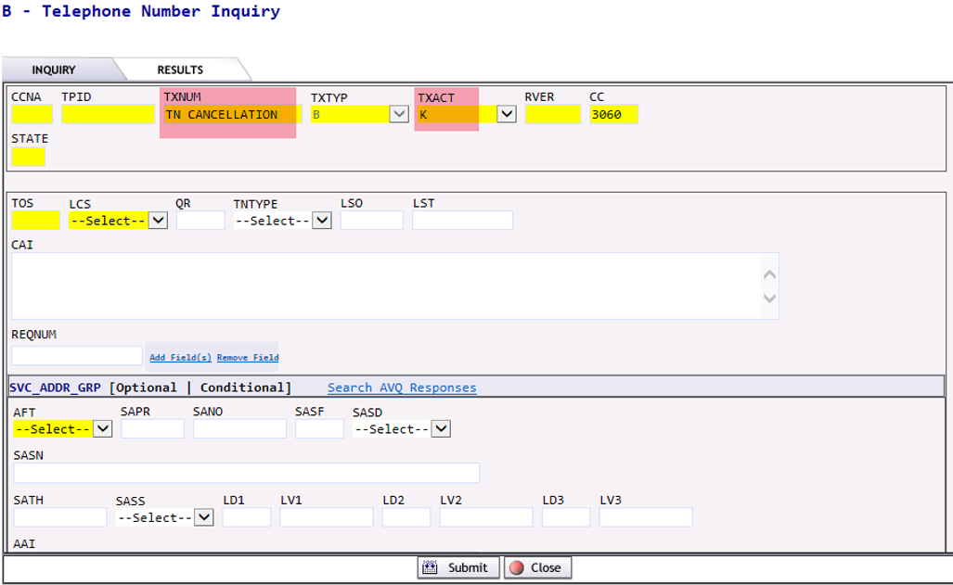

- Select the Submit button.

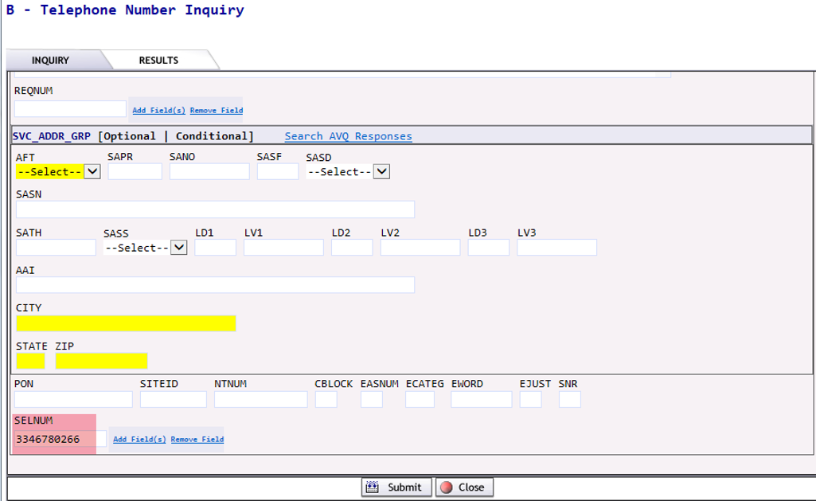

- A response will display indicating the number was successfully released.

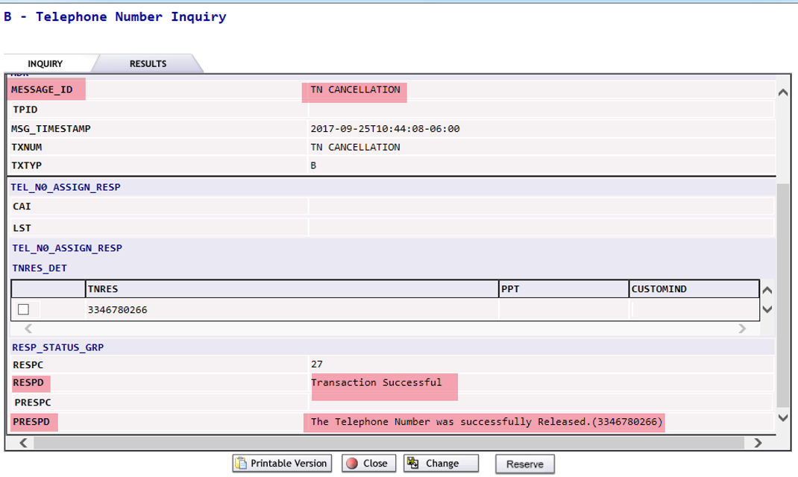

EASE Customer Service Information Inquiry (CSI) (TXTYP = E)
New functionality provides the ability to:
- View Customer Service Records (CSRs) with pending order activity applied based on a requested date.
NOTE: You are able to enter a current or future date in the CSR Date field. If a future date is entered and there are pending orders against the WTN or ECCKT, the activity specific to those orders will be applied against the current CSR and the result of the merged data will be displayed. This functionality is referred to as a Virtual CSR (VCSR) which will be identified with new fields on the response. A screen shot is provided below.
- View additional TN information at same address, for same customer
A Customer Service Information(CSI) inquiry can be executed within EASE for Pre-Order.

- Select New from the PREORDER tab.
- A PreOrder Initiation screenwill display. To execute a Customer Service Information inquiry, complete the following fields:
  - TXNUM – The system will pre-populate this field with a numeric value.

RECOMMENDATION: The user can override this information with the PON to be used during ordering to better track their inquiries.

  - TXTYP – Select E = Customer Service Information
  - Select the Initiate button.
- A Customer Service Information Inquiry screen will display.
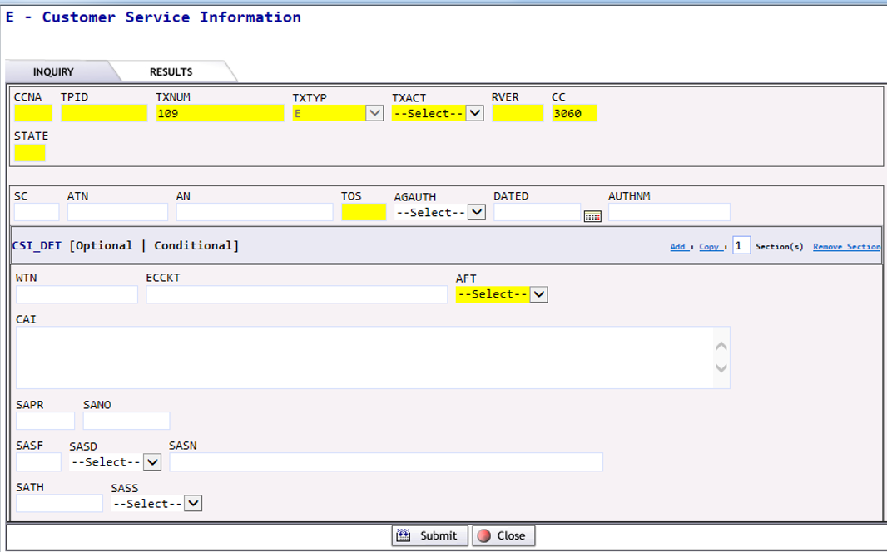
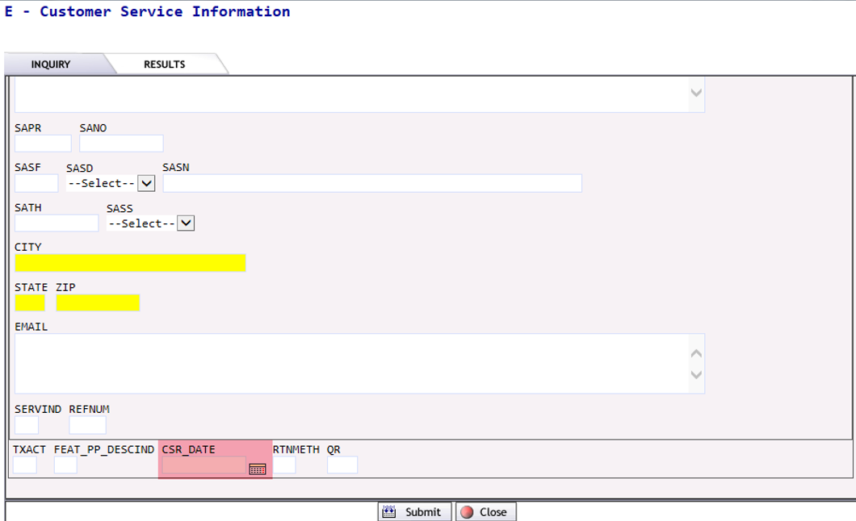
- Complete the following fields:
  - TXACT - Select A = New inquiry
  - STATE – Enter appropriate 2 digit state code in upper case.
  - AGAUTH = Y
  - WTN – Working telephone number at the enduser location.
Or
  - ECCKT – Provider’s Circuit Identification
  - CSR_DATE – A calendar is provided to enter either today’s date or a future date to determine if pending orders exist. If orders exist, the CSR will reflect all activity through the date entered in the CSR DATE field.
  - Submit.

CSR Response
CSR Response (continued)
The yellow highlighted area below indicates the number of FEAT_PP GRPs are returned for a given inquiry. To view all data update the number in ‘to’ to 89 for this example.
NOTE: You may find it easier to view if you select Printable Version.
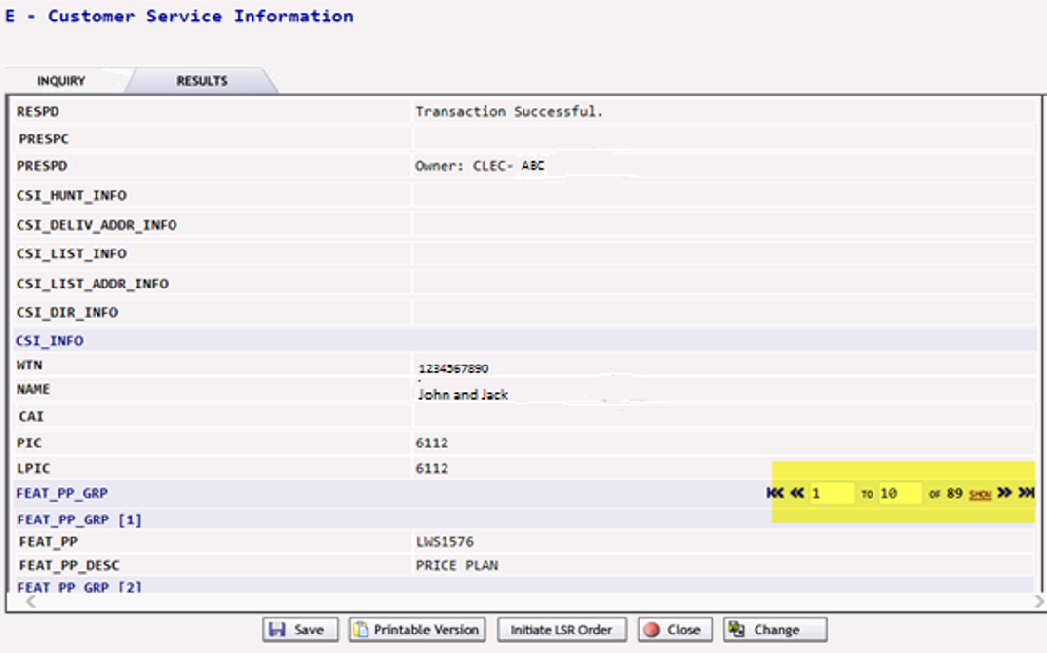
  - User is able to Save / Print / Close / Change the inquiry. In order to return to the address pre-order inquiry screen and modify the data, click on Change. The User is also able to create an LSR once the CSI has been retrieved using the Initiate LSR Order button.

The VCSR field indicates whether the CSR includes information for pending service orders as of the date entered in the CSR DATE field.
On the response when the VCSR entry is YES, the ORDER NUMBER, ORDER DUE DATE, and MERGE INDICATOR fields will be populated.
  - VCSR – If this field returns a YES value, it inidicates that there is pending order activity for the time up to the CSR DATE entered and the following fields will be populated.
  - PENDING ORDERS GRP – This group of fields may repeat depending on the number of order pending against this CSR.
    - ORDER NUMBER – This entry represents the service order number of the pending order.
    - ORDER DUE DATE – This entry represents the due date of the pending order.
    - MERGE INDICATOR – If this entry is Y, it indicates the pending order(s) was merged with the current CSR and the detail provided is a result of the merged order(s).
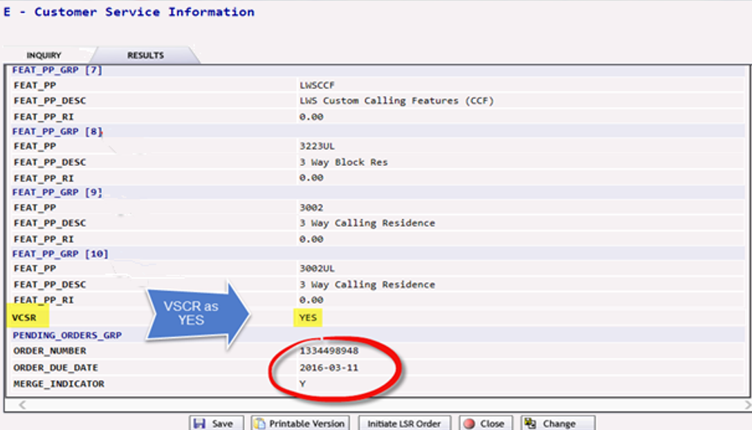

EASE Loop Qualification (Loop Qual) Inquiry (TXTYPE = H)
Loop qualifications serve to compile and filter loop network data for specific wholesale products. These qualification queries automatically analyze many attributes of technical network data and synthesize the data into a single simplified product-specific informational report. For instance, with Pre-Order Loop Qualification, you will be able to select:

- A validated address or working Brightspeed TN to be submitted for loop qualification of Resold Broadband Service, initially.
NOTE: The data will be provided on the A/V PRESPD response.
  - A loop qualification response will be returned either successful with the highest speed available for all applicable technologies (ATM, ADSL2+, VDSL2, etc.) and address - or return a non-qualified response.
- A validated address or Brightspeed TN with or without NC/NCI codes to be submitted for Unbundled ADSL loop qualification in a future release.
A Loop Qualification inquiry can be executed within EASE for Pre-Order.

- Select New from the PREORDER tab.

- A PreOrder Initiation screen will display. To execute a Loop Qualification inquiry, complete the following fields:
  - TXNUM – The system will pre-populate this field with a numeric value. RECOMMENDATION: The user can override this information with the PON to be used during ordering to better track their inquiries.
  - TXTYP – Select H = Loop Qualification
  - Select the Initiate button.

- A new Loop Qualification Inquiry screen will display.

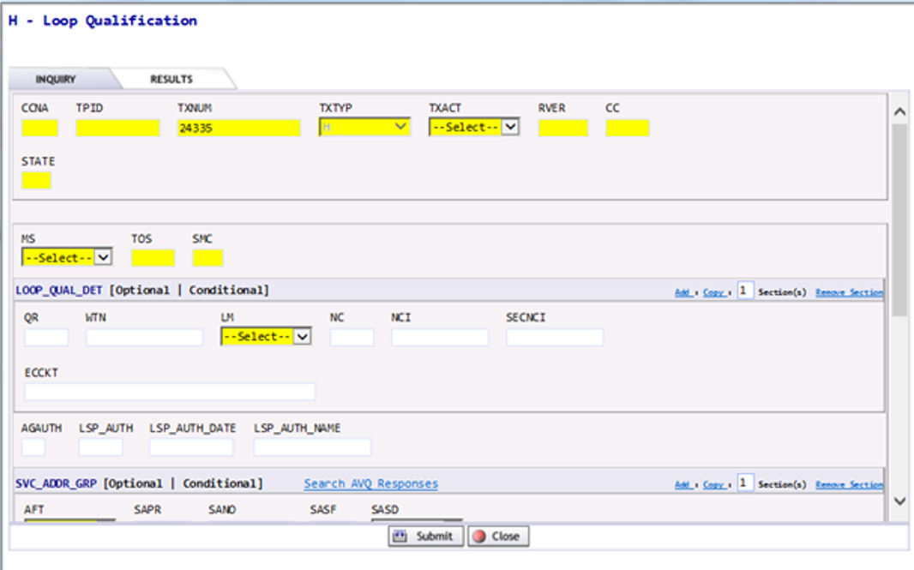

- Complete the following fields.
  - TXACT - Select A = New inquiry.
  - STATE – Enter appropriate 2 digit state code in upper case.
  - MS – Select A.
    - A = Resale
    - B = Unbundled NOTE: The B option will be available in a future release.
- Enter data for search:
  - WTN
    - MS = A by WTN provides Loop Qual and Loop Data
or

  - Address detail in the SVC_ADDR_GRP fields
    - MS = A by Address provides Loop Qual only

Loop Qual provides the following elements in the LOOPQUALMESG field:
- Technology (ATM, ADSL, VDSL)
- Qualifying speeds

Loop Data provides the following elements:
- LOOPSTAT = Loop Status (Qualified, Not Qualified)
- LST = Local Service Termination (6 character CLLI)
- LLT = Loop Length Type (Actual, Estimated, Electrical)
- ELL = Equivalent Loop Length
- ECCKT = Exchange Company Circuit ID
- PGRES = Pair Gain Presence (Actual, Estimated)
- F1LPCP = F1 Loop Composition (Coaxial, Copper, Fiber)
- F2LPCP = F2 Loop Composition (Coaxial, Copper, Fiber)
- LCQ = Load Coil Quantity
- BTQ = Bridged Tap Quantity
- WTN = Working TN
- GA = Guage (diameter of cable)
- LU = Length Unit (FT, KFT, KM, MI)
- LLG = Loop Length by Guage
- LL = Loop Length

- Submit.

Loop Qualification Inquiry with MS = A (Resale) by Address

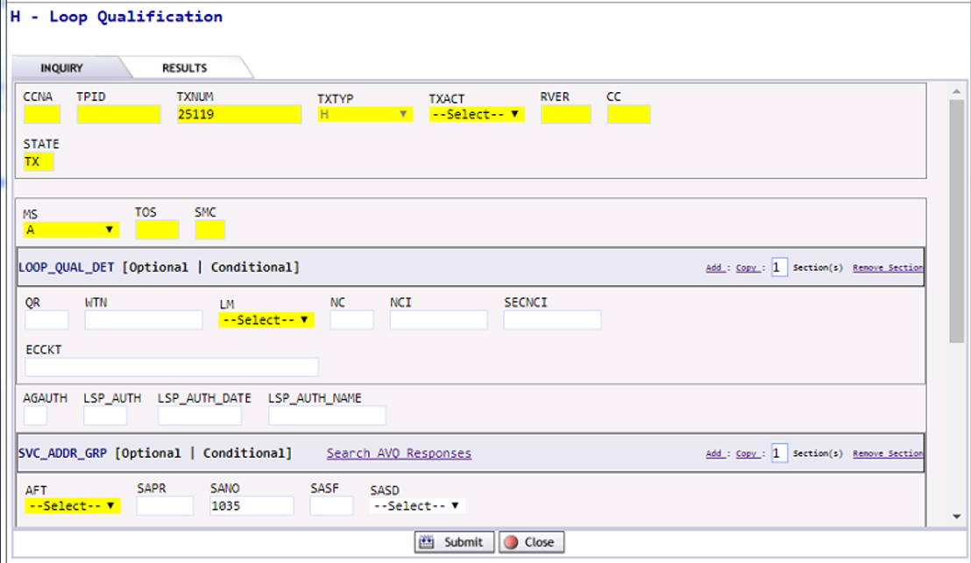

Loop Qualification Inquiry with MS = A (Resale) by Address (continued)

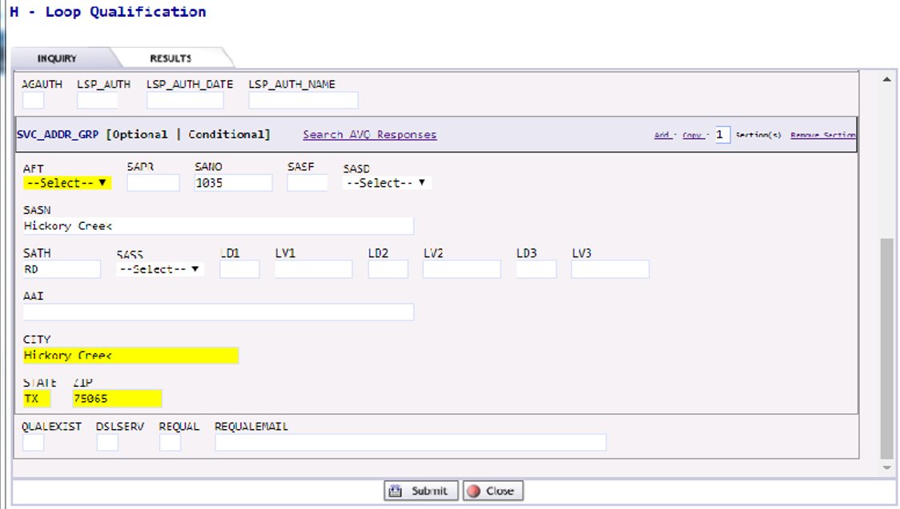

Based on the information entered on the Loop Qualification Inquiry tab, the system will execute the request and provide a response upon submission.

The Loop Qualification response results will display in the Results tab fields.

Loop Qualification Results with MS = A (Resale) by Address
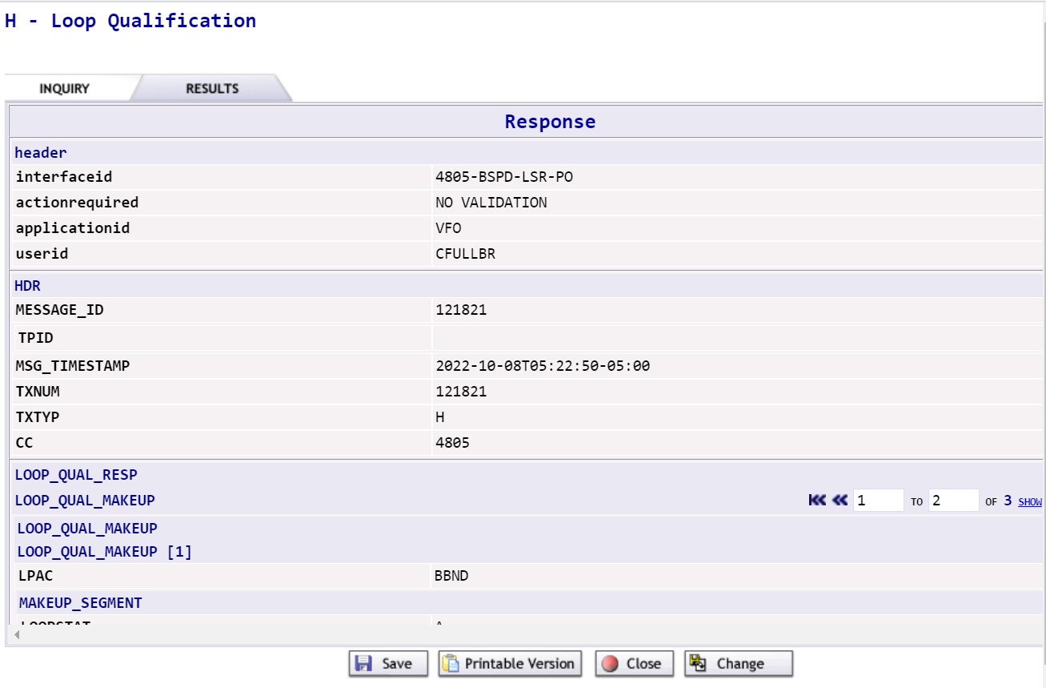
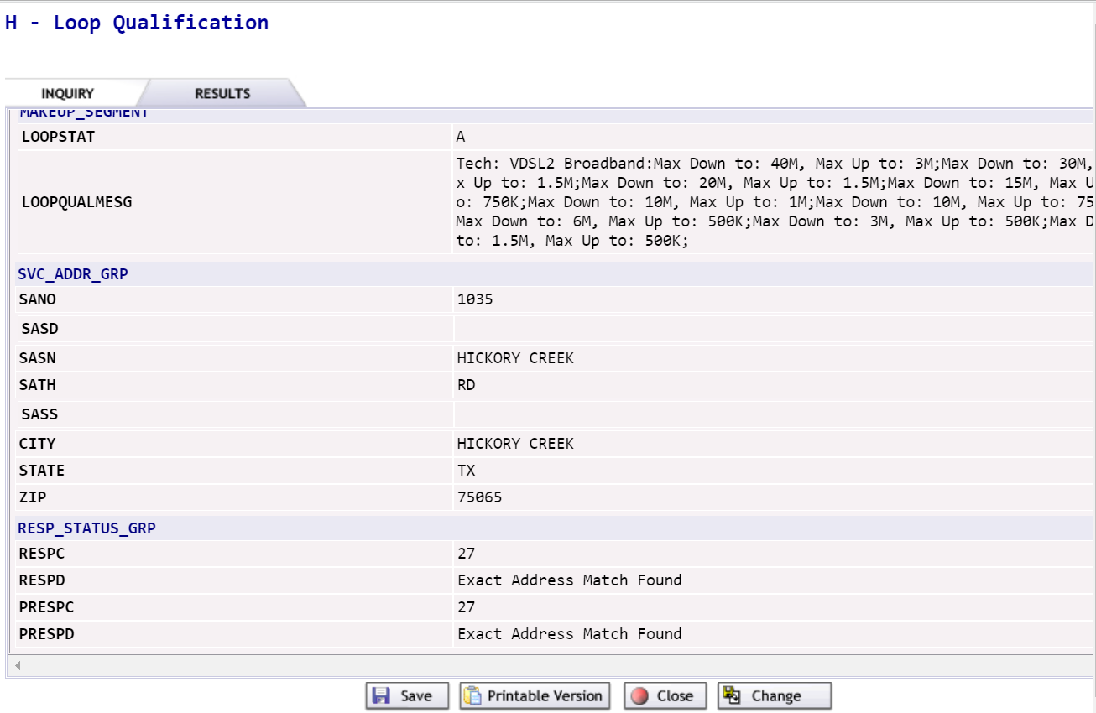

Loop Qualification Inquiry with MS = A (Resale) by WTN
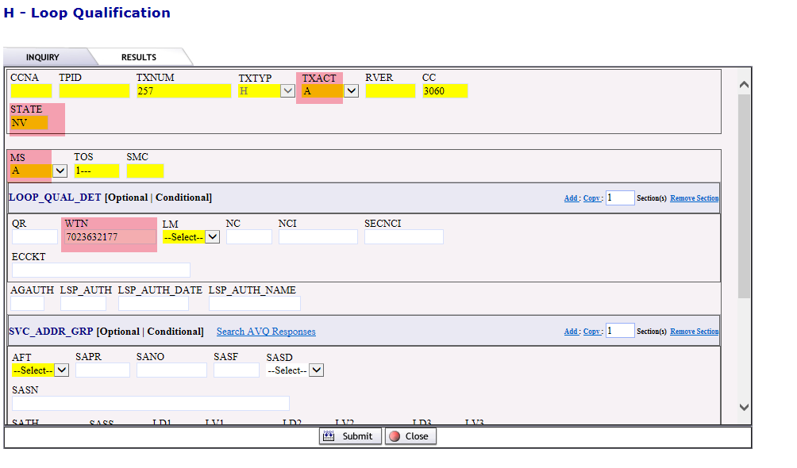

Loop Qualification Results with MS = A (Resale) by WTN

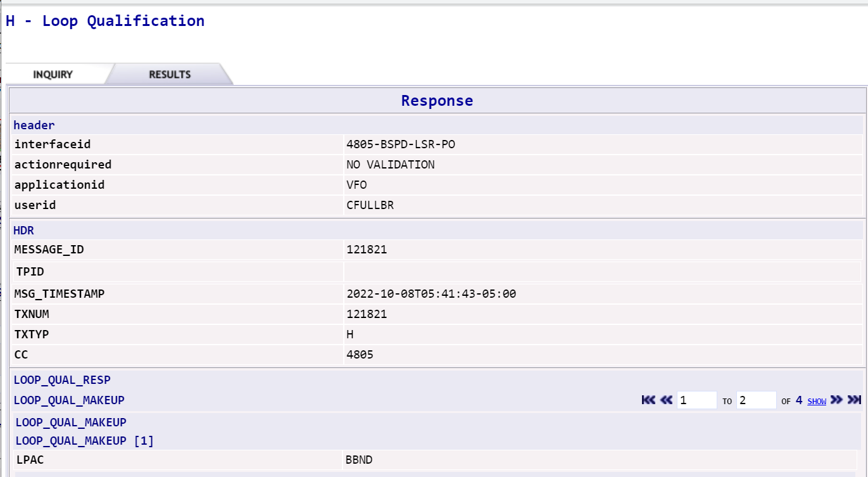

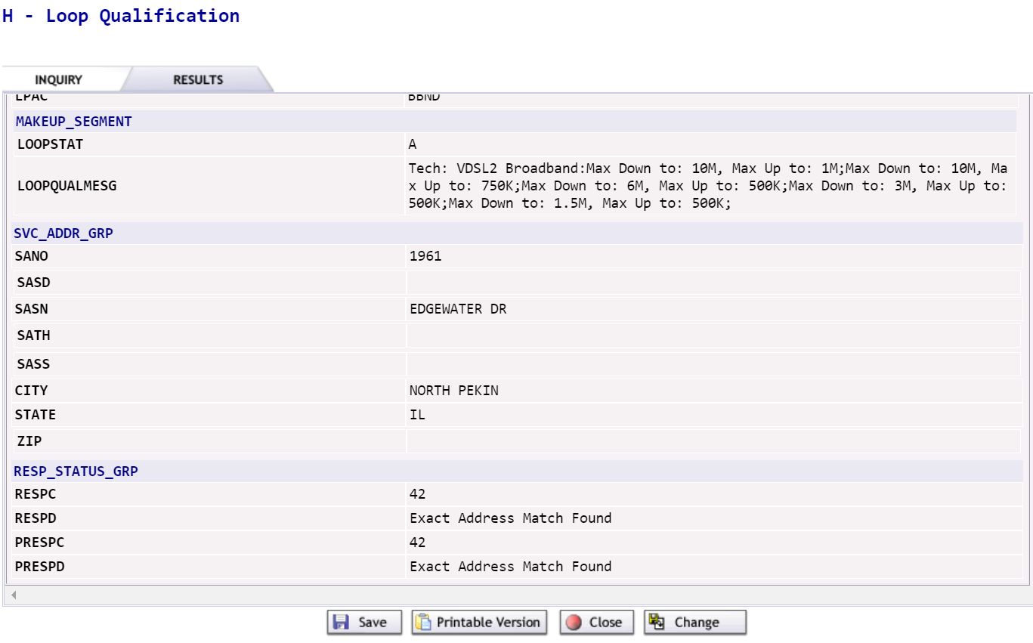

  - User is able to Save / Print / Close / Change the inquiry. In order to return to the address pre-order inquiry screen and modify the data, click on Change.

RECOMMENDATION: Many Loop Qual Results are extremely lengthy. In order to easily see all detail, select Printable Version.

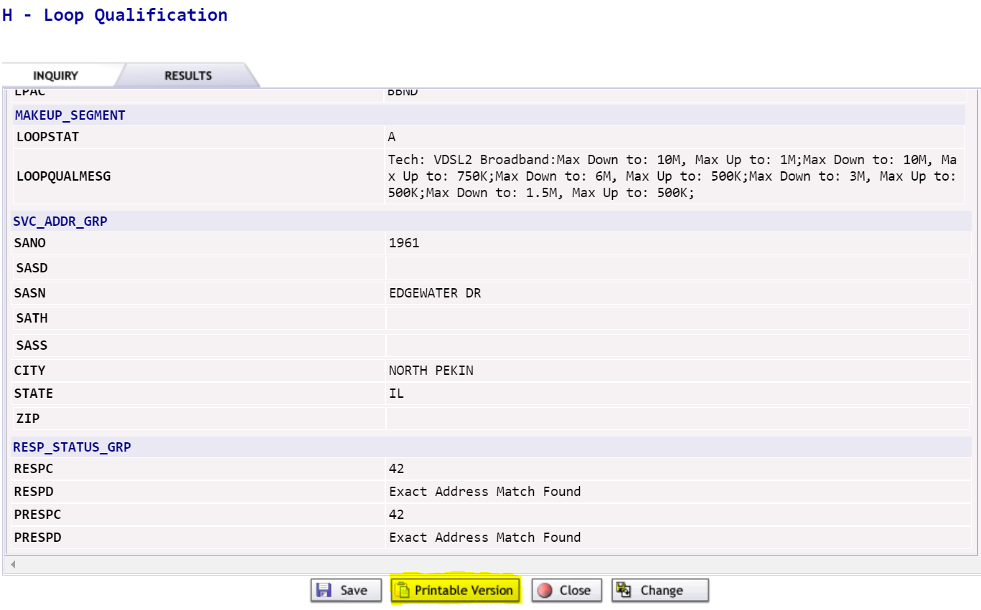

EASE Raw Loop Data (RLD) Inquiry (TXTYPE=R)
This Pre-Order function retrieves Raw Loop Data by segments and sub-segments. Data may be queried by:
- WTN
- Circuit for designed services
- Valid address
- Assigned services
- Unassigned or spare services (Unassigned or spare facilities searches will not initially be availabable. They will be introduced in a future release.)

A Raw Loop Data inquiry can be executed within EASE by selecting New from the PREORDER tab.
- A PreOrder Initiation screenwill display. To execute a Raw Loop Data inquiry, complete the following fields:
  - TXNUM – The system will pre-populate this field with a numeric value.

RECOMMENDATION: The user can override this information with the PON to be used during ordering to better track their inquiries.

  - TXTYP – Select R = Raw Loop Data
  - Select the Initiate button.
- A new Raw Loop Data Inquiry screen will display.

Raw Loop Data Inquiry

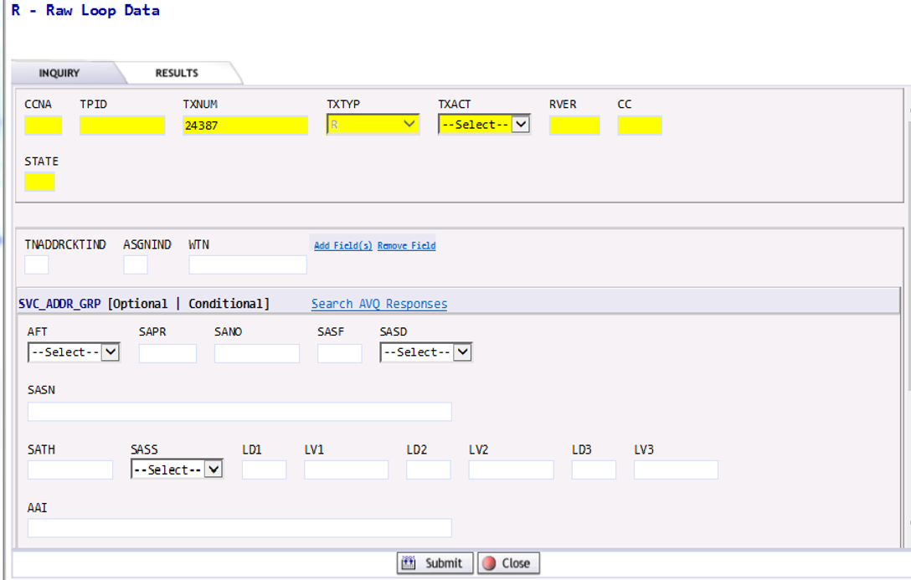

- Complete the following fields.
  - TXACT - Select A = New inquiry.
  - STATE – Enter appropriate 2 digit state code in upper case.
  - TNADDRCKTIND (Telephone Number, Address, Circuit Indicator) – Enter appropriate 1 digit code of:
    - T = Telephone Number
    - A = Address
    - C = Circuit
- If you are searching by WTN, do not enter address or ECCKT (Circuit) detail.
  - WTN – Enter the working telephone number at the end user’s location when querying RLD by TN. Selecting the Add Field link, will add additional occurances of WTN fields based on the number requested in the Add Field elements box or selecting additional Add Field links.

NOTE: WTNs can be for different end users and different addressses.

Add Field elements dialog box

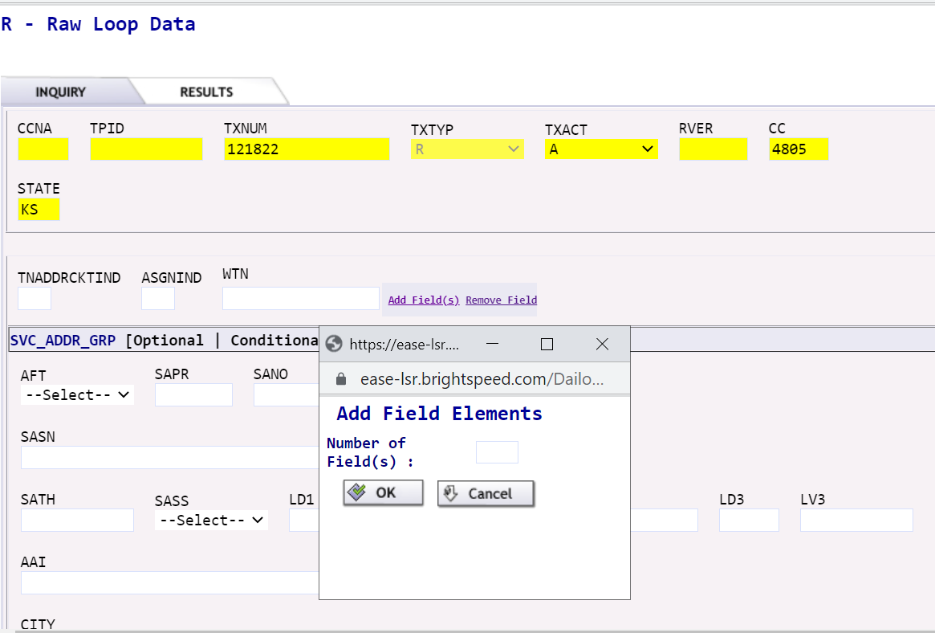

In this case, two fields were requested. A total of three WTN fields now display.

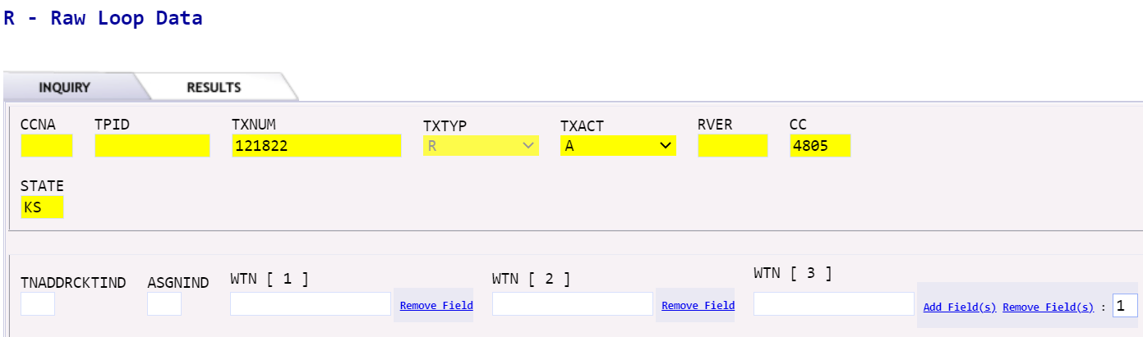

You may also remove WTN fields by selecting the Remove Field(s) link.

- If you are searching by Address, you must populate the ASGNIND field.
  - ASGNIND (Identifies if RLD is looking for makeup of assigned services or spare services.) Enter A for assigned or U for unassigned or spare.

NOTE: Unassigned or spare facilities searches will not initially be available. They will be introduced in a future release.

  - SVC ADDR GRP – Enter appropriate address fields when querying RLD for Assigned or Unassigned by Address.

The minimum Address field entries are:
- SANO identifies the number of the service address.
- SASN identifies the street name of the service address.
- SATH identifies the thoroughfare portion of the service address, such as LN (lane) or BLVD (boulevard).
- CITY identifies the city, village, or township.
- STATE identifies the abbreviation for the state or province.
- ZIP identifies the ZIP or postal code.
NOTE: Additional Address Detail fields may be populated if they apply to the inquiry address:

- AFT identifies the format of the address being supplied. Valid entries:
    - A = Rural Route and/or box number
    - B = Unnumbered
    - C = Provider Assigned house number
    - D = Descriptive
    - E = Provisioning Adddress
  - SAPR identifies the prefix for the address number of the service address.
  - SASF identifies the suffix for the address number of the service address.
  - SASD identifies the street directional prefix for the service address. Valid entries:
- E = East
- W= West
- N = North
- S = South
- NE = Northest
- NW = Northwest
- SE = Southeast
- SW = Southwes
- SASS identifies the street directional suffix for the service address. Valid entries are shown below.
- E = East
- W= West
- N = North
- S = South
- NE = Northest
- NW = Northwest
- SE = Southeast
- SW = Southwest

- LD1, LD2, LD3 identifies additional specific information related to the address. Valid entries:
  - LD1
    - APT
    - LOT
    - RM/ROOM
    - SLIP
    - UNT/UNIT
    - STE/SUIT
  - LD2
    - FL/FLR
  - LD3
    - BLDG
    - WNG
    - PIER
- LV1, LV2, LV3 identifies the value associated with the location designator
- AAI identifies additional location information about the address.

NOTE: Previously, the AAI field was required to be populated if there is additional detail specific to the address such as room, apartment, suite, floor, etc.

With this implementation, supplemental address information may be entered in either the LD/LV or the AAI fields. EASE will accept input in either and send the data downstream.

Supplemental data can be entered in any LD/LV fields. Entries are not specific to LD1 vs. LD2 vs. LD3 at this time.

LD/LV fields edit for USPS data content like UNIT. The AAI field edits for MARTENS data content like UNT.

Presently, supplemental data for complex addresses will be returned in the AAI fields.

Saved addresses with supplemental data will prepopulate in the AAI field but can be changed and typed in individual LD/LV fields.

  - Submit

- If you are searching by Circuit, you must populate the following fields.
  - LSO – Enter the primary NPANXX associated to the ECCKT.
  - ECCKT – Enter the provider’s circuit identification.
  - Submit.

Based on the information entered on the Raw Loop Data Inquiry tab, the system will execute the request and provide a response upon submission.

The Raw Loop Data response results will display in the Results tab fields.

  - User is able to Save / Print / Close / Change the inquiry. In order to return to the address pre-order inquiry screen and modify the data, click on Change.

Raw Loop Data Inquiry by TN

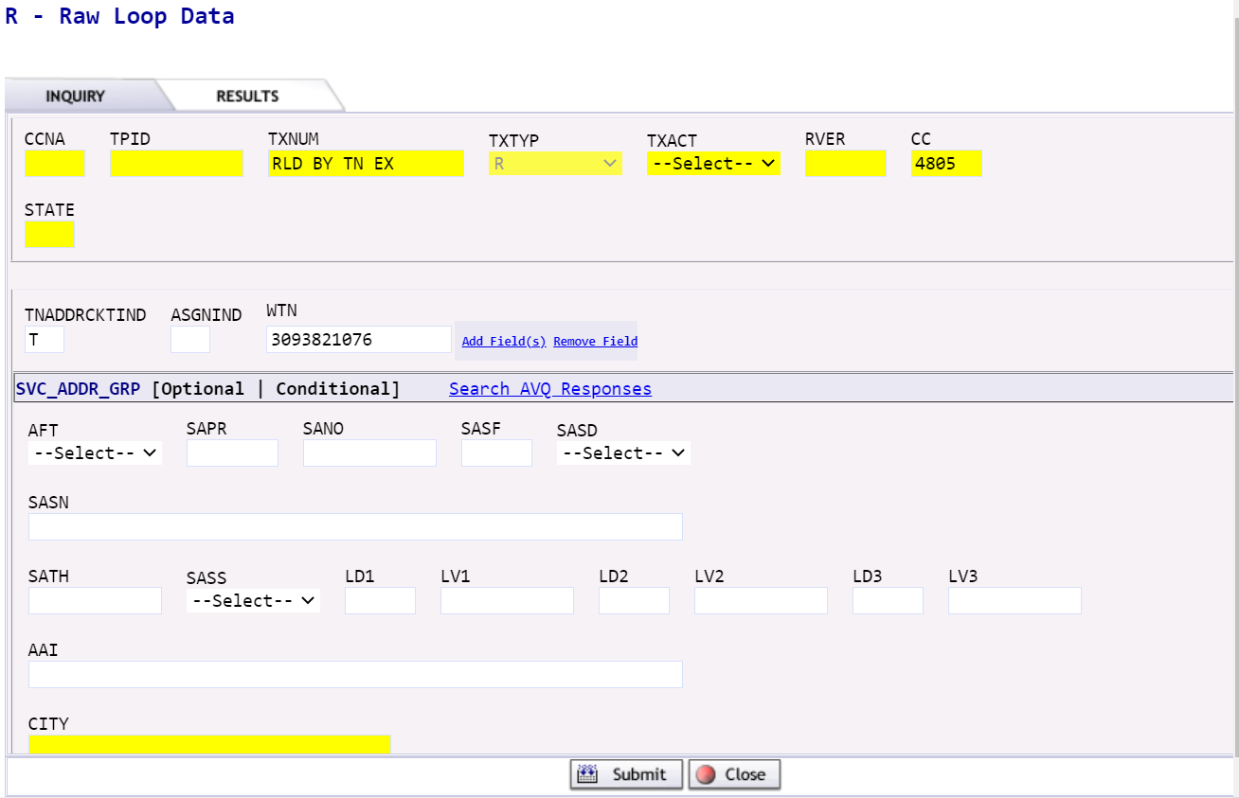
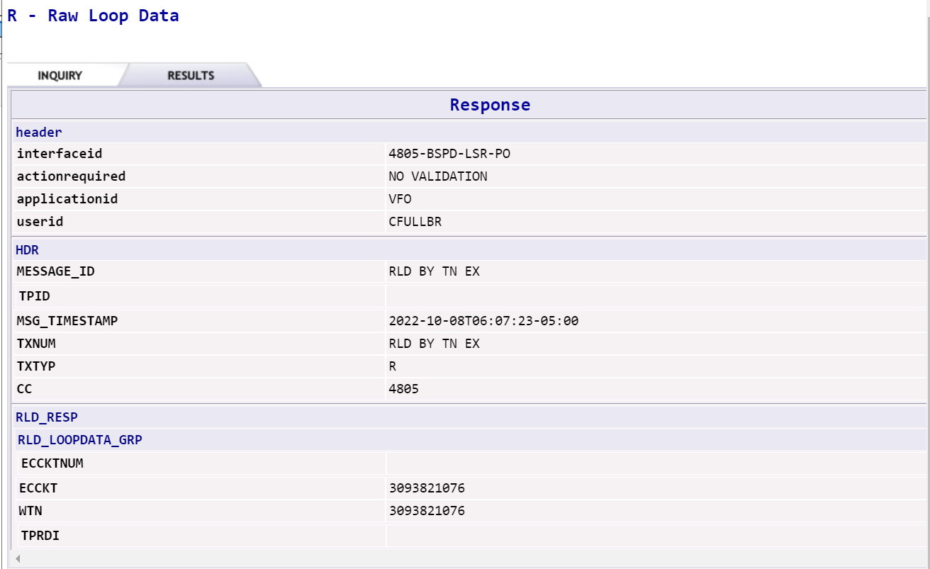

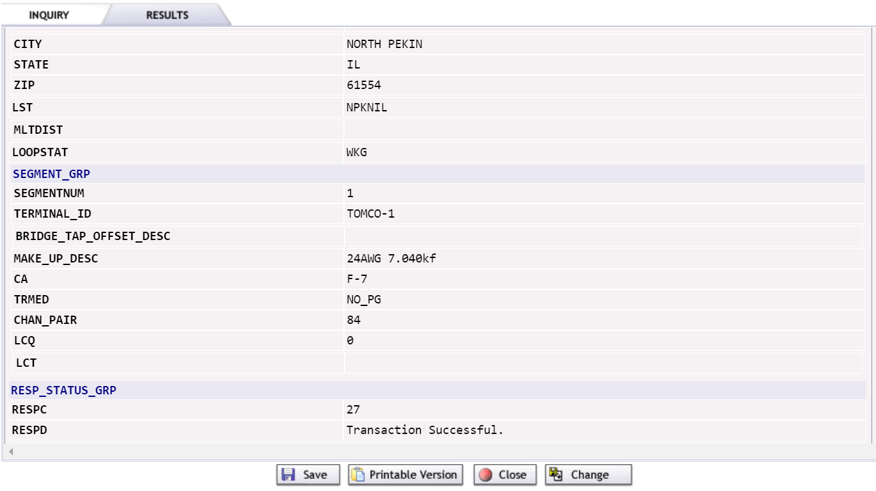

Raw Loop Data Inquiry by Assigned Address
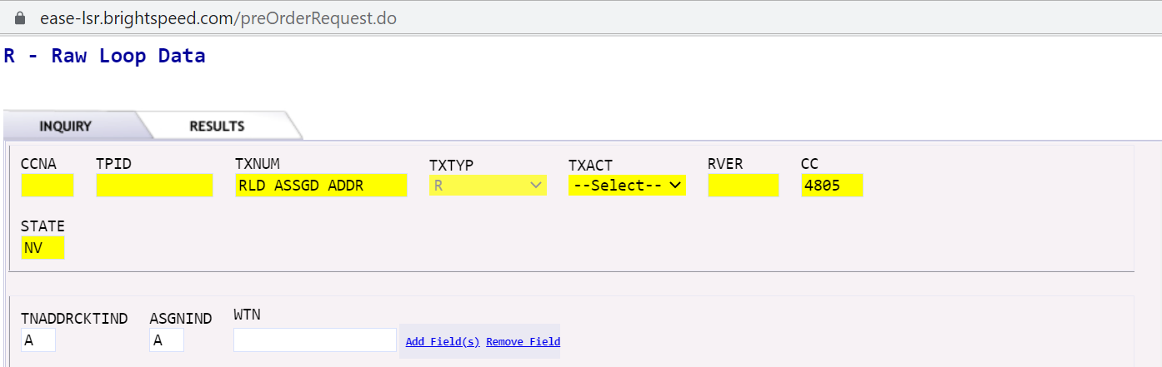
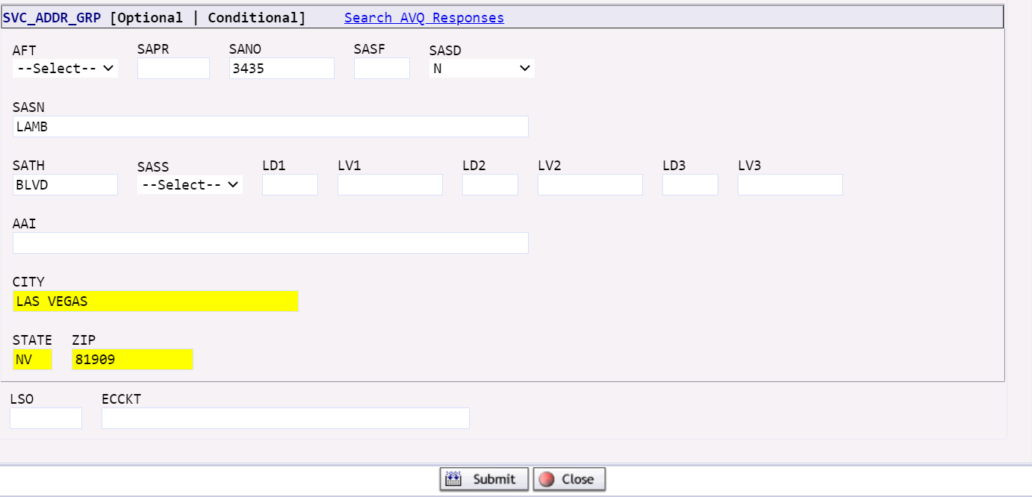

Raw Loop Data Inquiry by Assigned Address (continued)

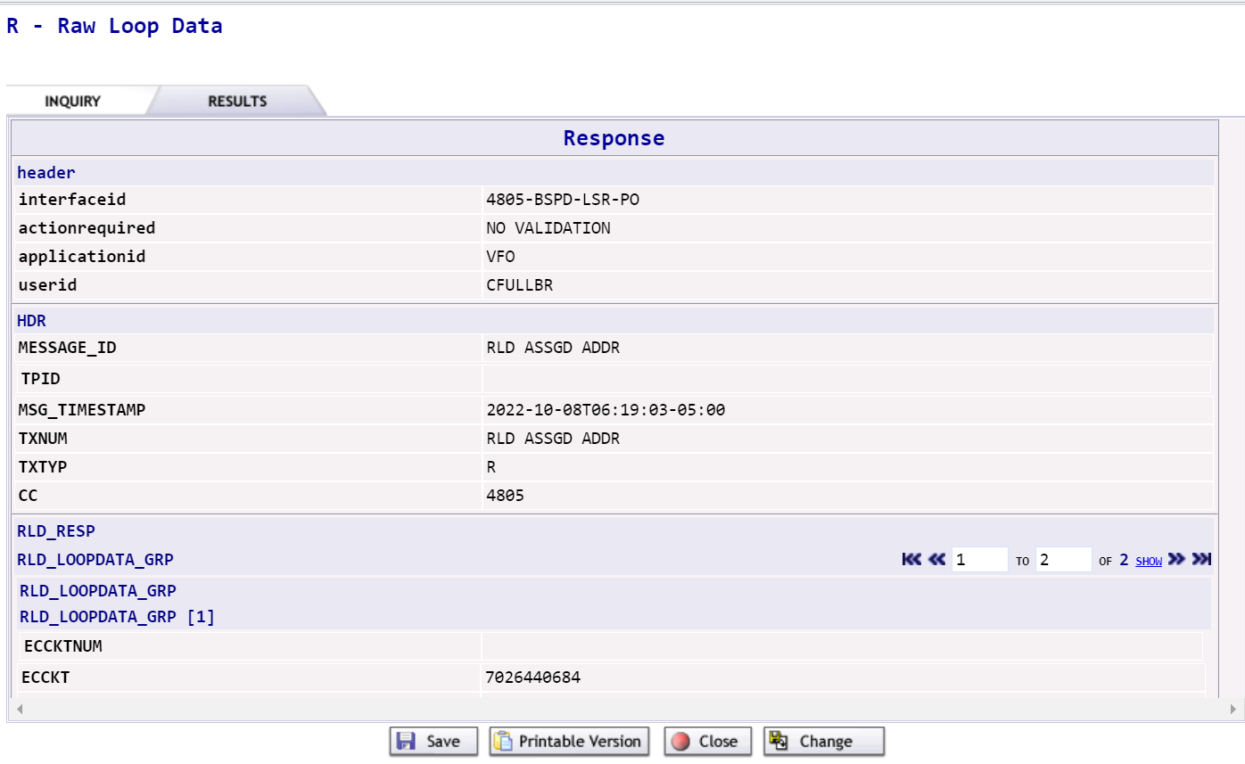
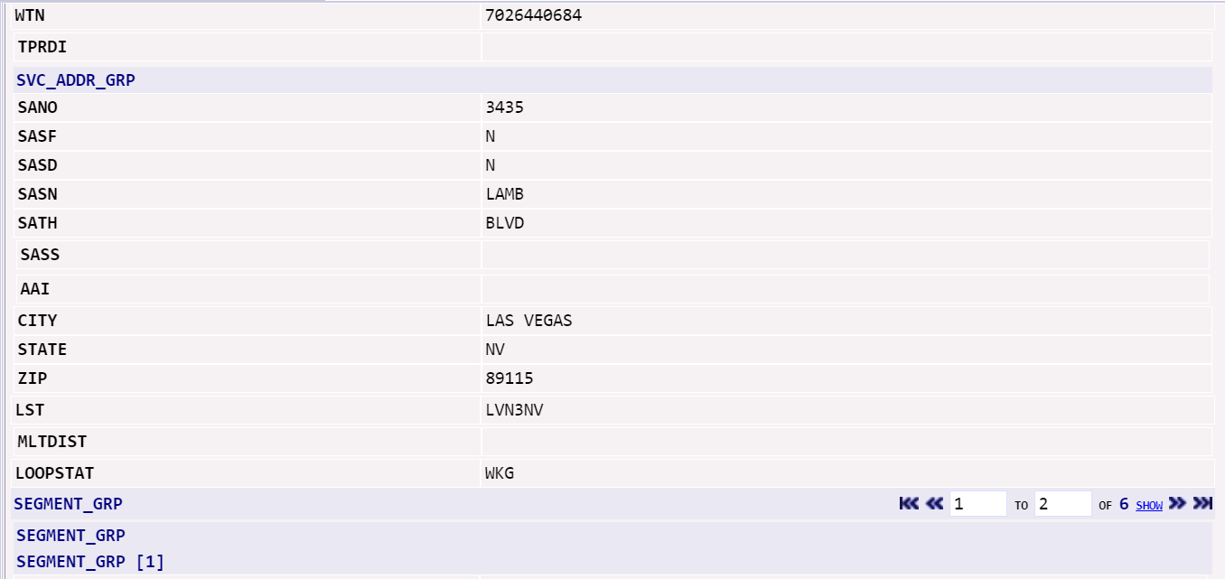

Raw Loop Data Inquiry by Assigned Address (continued)

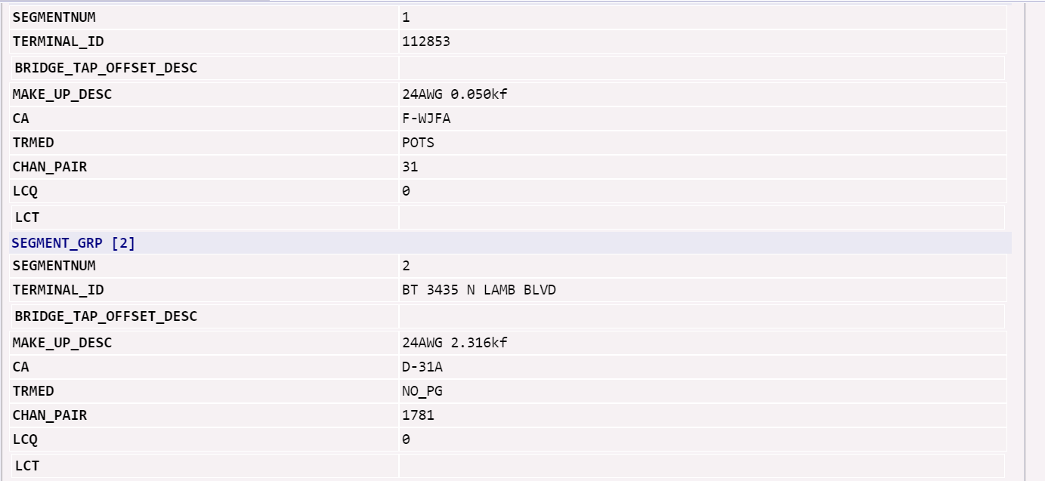
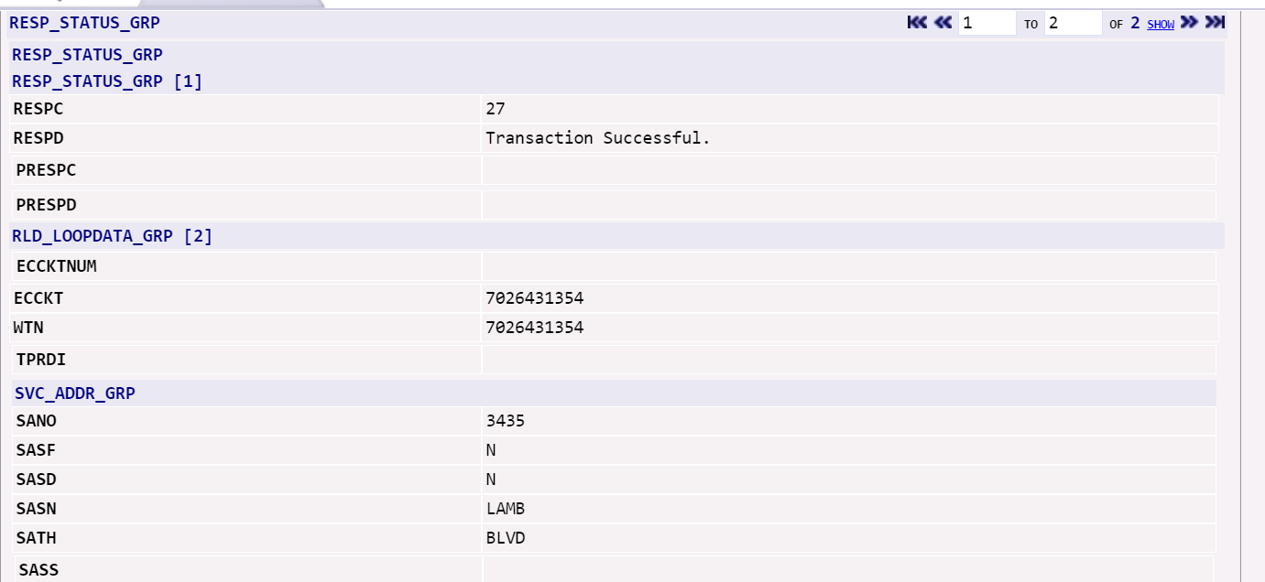

Raw Loop Data Inquiry by Assigned Address (continued)

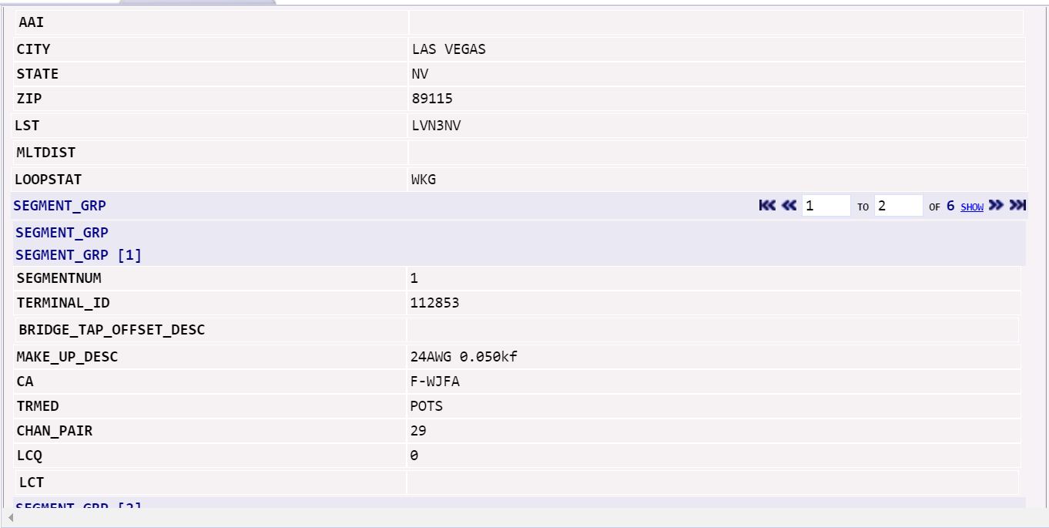
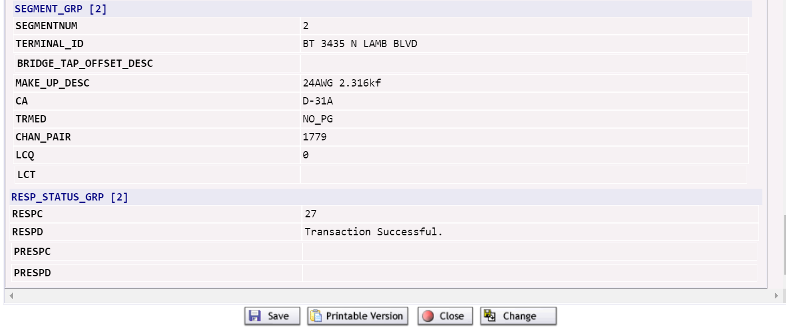

Raw Loop Data Inquiry by Circuit
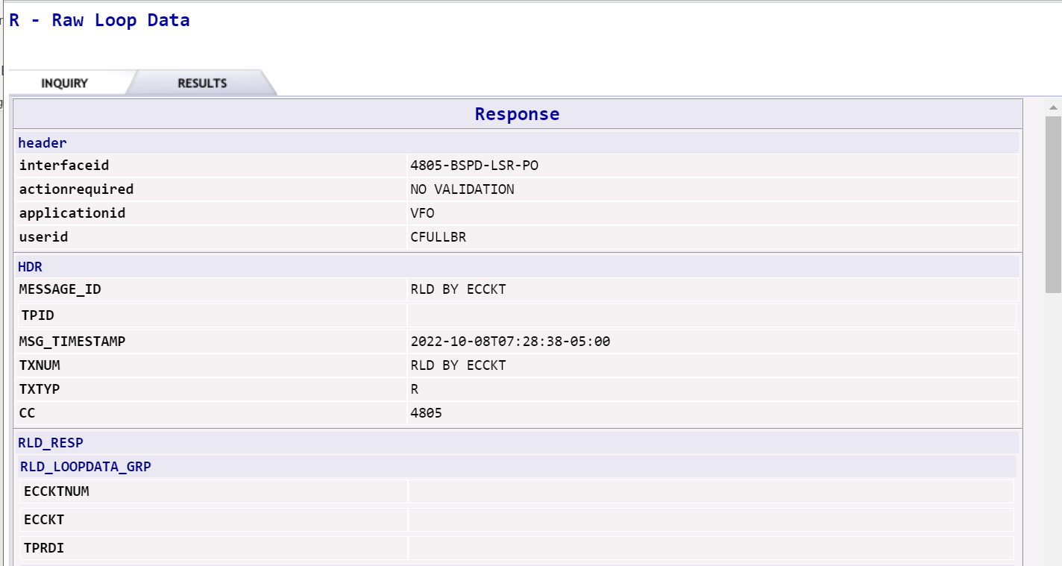
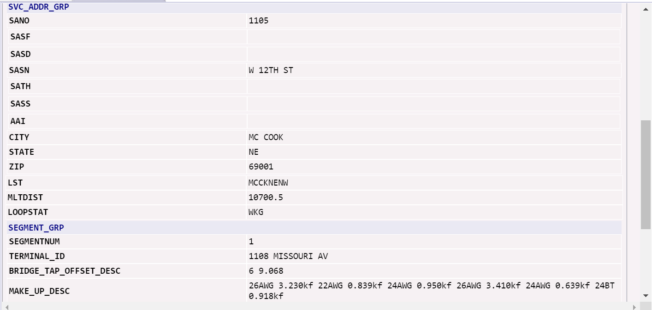
Raw Loop Data Inquiry by Circuit (continued)

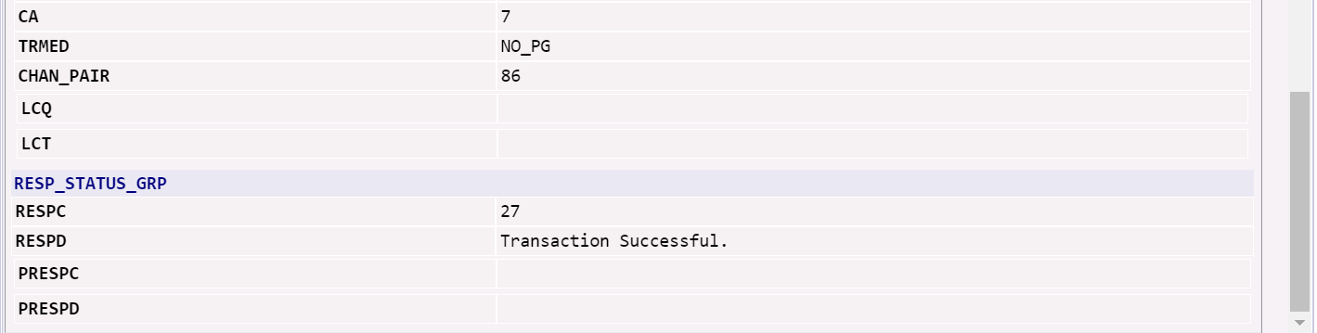

EASE Listings for Telphone Number Inquiry or DLI Directory Listing Inquiry (TXTYP = T)
The Listings for Telephone Number or DLI (Directory Listing Inquiry) provides new functionality that supports:
- Viewing Caption Name using a wild card option
- Retrieving listing information using the YPPA code

A Directory Listing inquiry (DLI) can be executed within EASE for Pre-Order.

- Select New from the PREORDER tab.
- A PreOrder Initiation screen will display. To execute a DLI, complete the following fields:
  - TXNUM – The system will pre-populate this field with a numeric value. RECOMMENDATION: The user can override this information with the PON to be used during ordering to better track their inquiries.
  - TXTYP – Select T = Listings for Telephone Number.
  - Select the Initiate button.
- A new Directory Listings Inquiry screen will display.

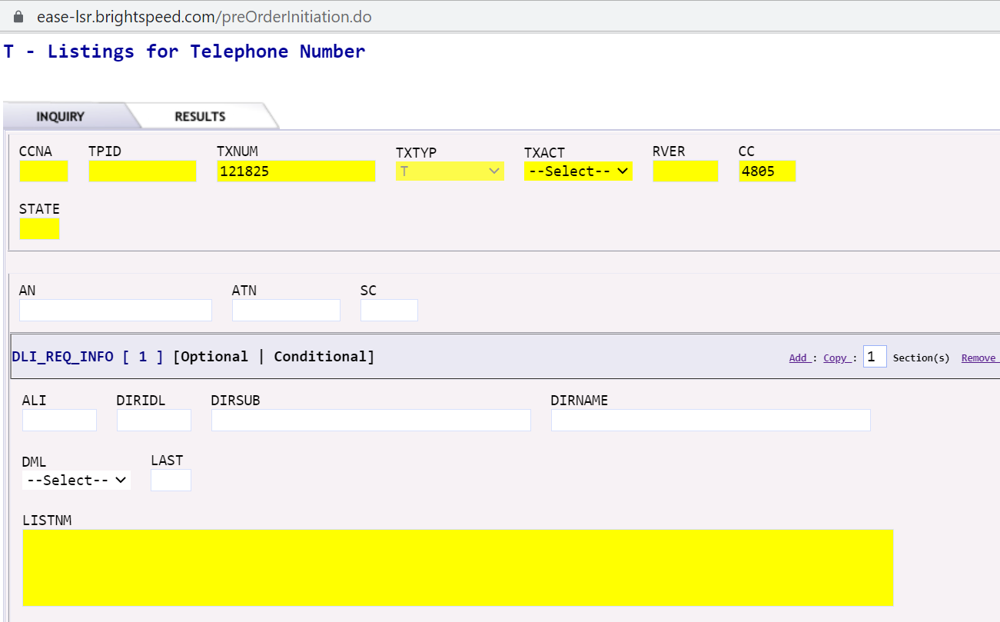

- Complete the following fields.
  - TXACT - Select A = New inquiry.
  - STATE – Enter appropriate 2 digit state code in upper case.

- In the DLI_REQ_INFO section, populate at least the following fields and Submit.

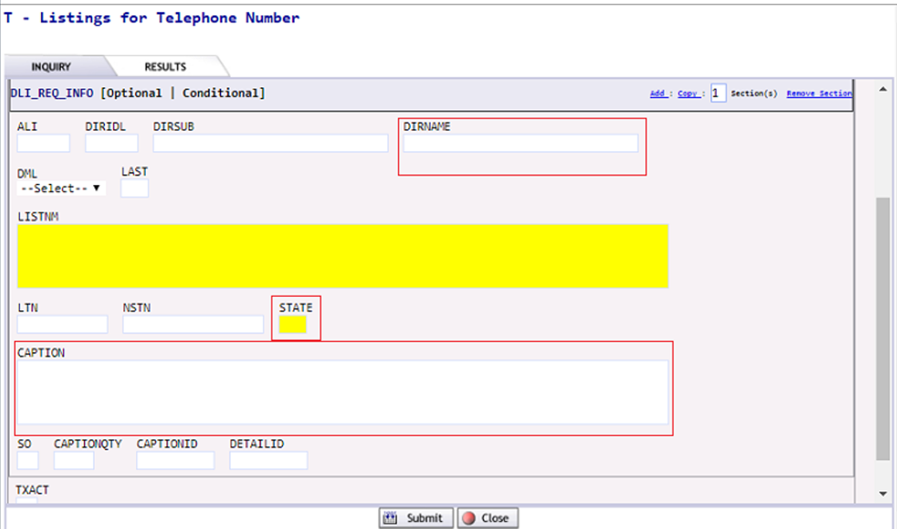

  - DIRNAME - Identifies the name of a directory in which to place the listing. Either the directory name or the YPPA code corresponding to that directory can be entered here.

NOTE: If the directory name is entered, it has to be exact. Both YPPA Code or Directory Name can be retrieved from the External App Data for View Directory Name on the LSR Order Menu option on the Order List page.

  - STATE - Enter appropriate 2 digit state code in upper case.
  - CAPTION – Populate this field with one of the following: Entire caption name, one/two or more words, or a partial caption name.
  - Submit.

  - If partial caption name, one or more words or a wild card character (%) can be entered, based on a selection list that will be displayed. In the example below, the word ‘okaloosa’ was typed in the Caption field.

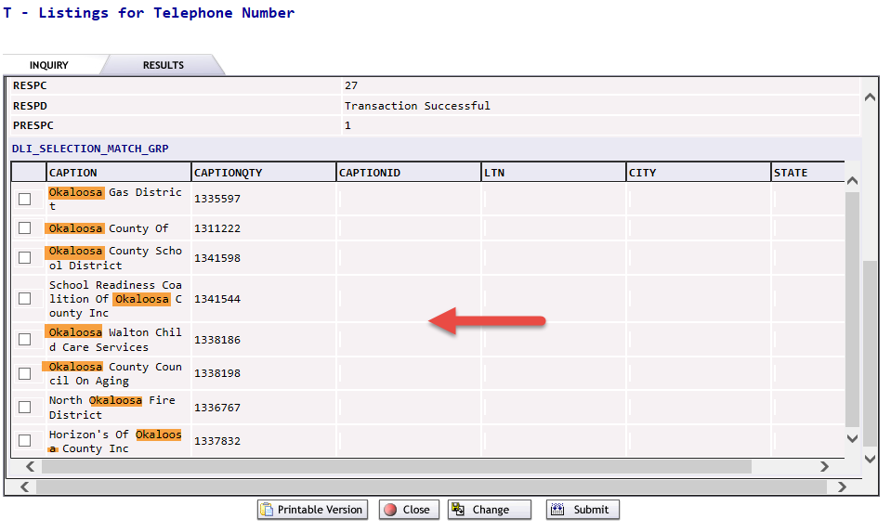

  - Select the required caption name and click Submit to see the listing detail.

Changes and/or Additions

Upgrade from LSOG 10 to LSOG 2Q14
With the implementation of EASE LSR enhancements, Brightspeed has upgraded from LSOG 10 to LSOG 2Q14, providing access to a more current OBF LSOG version. A document indicating the Brightspeed specific differences between LSOG 10 and LSOG 2Q14 is provided in the Technical Specifications. XML schemas that support the UOM-LSR also reflect the changes.

All associated documentation can be found at https://ease.brightspeed.com. Then select Guide > LSR > Brightspeed 2Q14 Files.

Auto-populate pre-order validated addresses into the LSR
A list of previously validated addresses will be available for selection and population into the LSR or to a Telephone Number Inquiry, Loop Qualification, or Raw Loop Data pre-order.
- Select the Search AVQ Responses link on the Order screen.

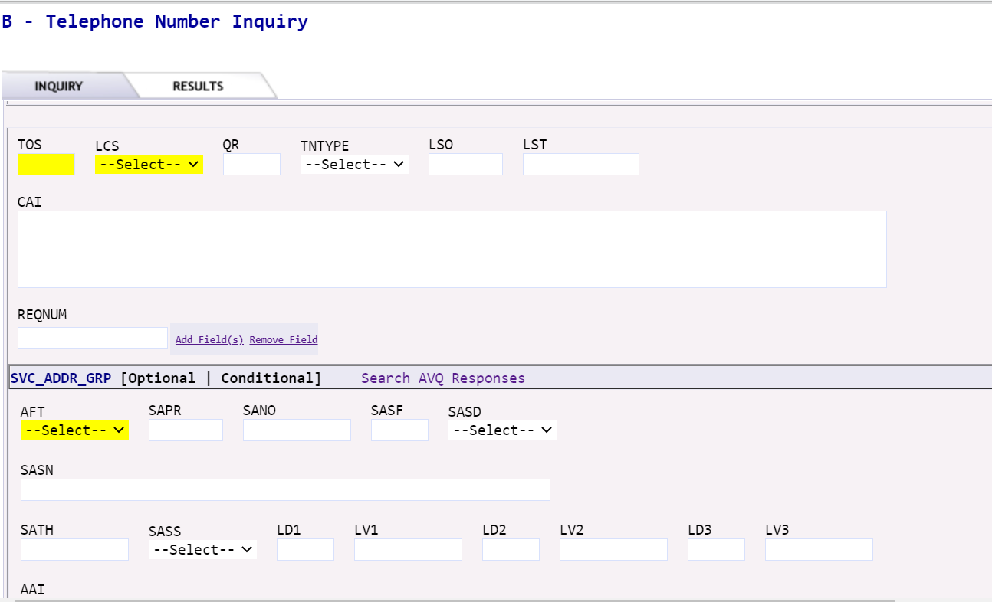

- The PreOrder Search screen will display.
- Select a saved Preorder with the appropriate address. This is done by hovering over the TXNUM you want to select until a link displays.

NOTE: This is where using a PON for the TXNUM can assist in the ordering process.

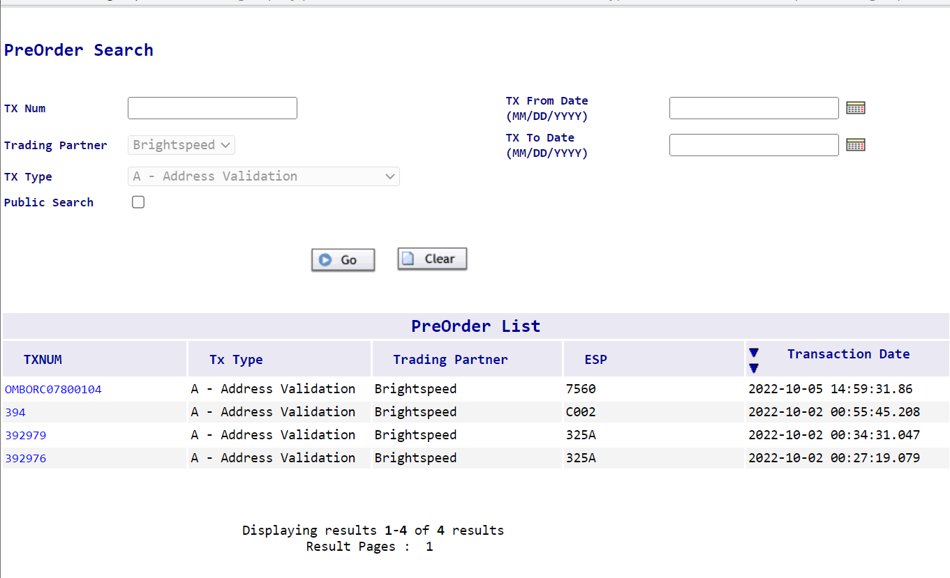

- The Address Validation screen will display.
- Hover over the appropriate TXNUM value link and click it.
- The associated saved Address Validation screen will display.

- Select the Prepopulate link on the Address Validation screen.

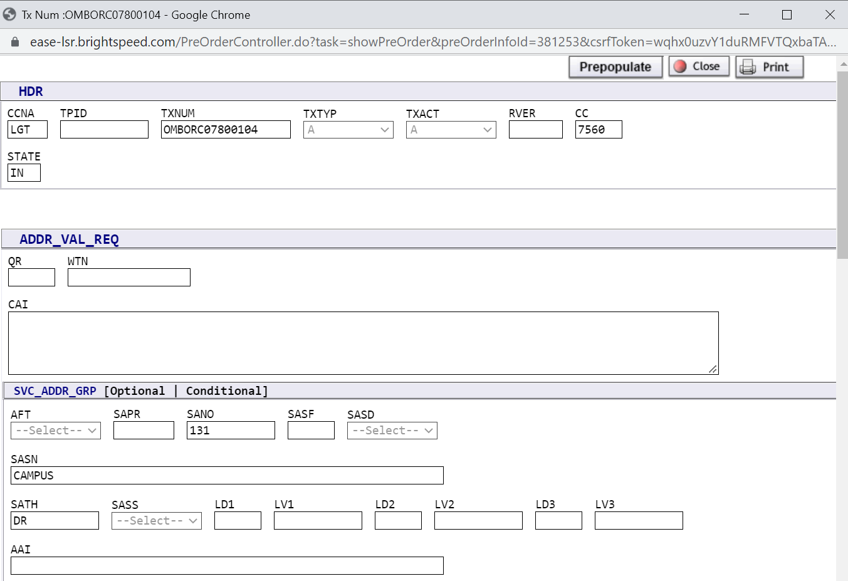

Auto-populate reserved Telephone Number(s) (TN) into the LSR
A list of previously reserved TNs will be available for selection and population into the LSR from the PreOrder Search screen.
- Select the Search Pre-Order link on the Order screen.
- The PreOrder Search screen will display.
- Select a saved Preorder with the appropriate TN Reservation by hovering over the appropriate TXNUM value link and clicking it.

NOTE: This is where using a PON for the TXNUM can assist in the ordering process. On the list below, notice the difference in a system assigned TXNUM vs. one that you name. The naming convention you choose makes it easier to match up to a specific PON associated to the pre-order activity so you can select and autopopulate the detail to the LSR request.

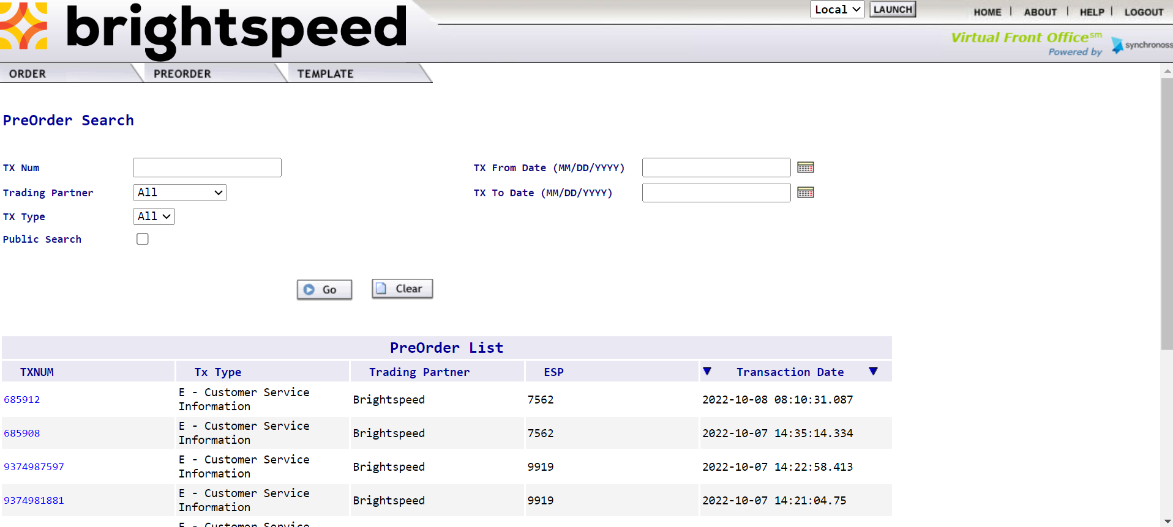

- The associated saved TN Reservation screen will display.

- Select Prepopulate link on the TN Reservation screen.

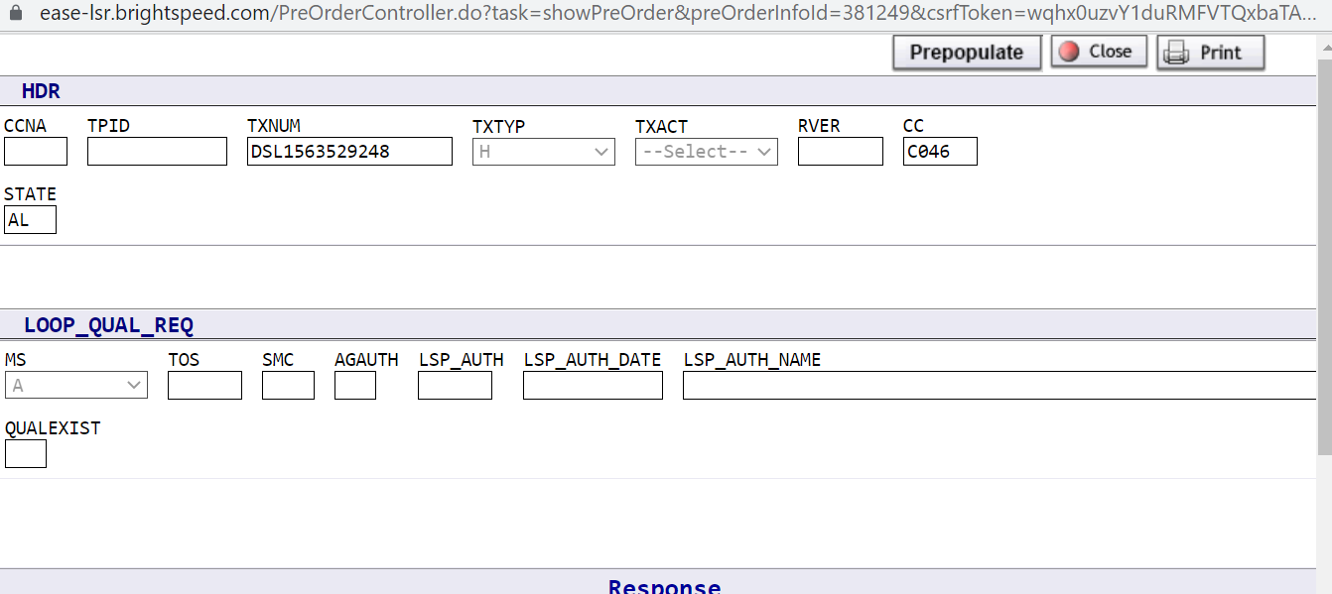

- The Reserved TN selected will automatically populate in the TNS field on the RS (Resale Service) form for REQTYP = EB and MB and on the CRS (Centrex Resale Services) form for REQTYP = MB and and PB.

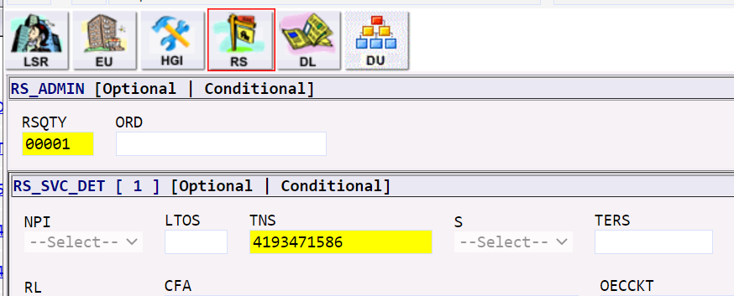

New Shipping Address section added to the End User (EU) form
A new section on the End User (EU) form has been added to accommodate the shipping of broadband equipment. When the USE_SERVICE_ADDR field is populated with NO, the associated shipping address fields must be populated. If the USE_SERVICE_ADDR field is blank, then the EU address is the default when the request is ordering a modem.
NOTE: The address needs to match USPS.COM addressing. However, modems are shipped by UPS so PO Boxes are not allowed.
SHN1 – Shipping Name
SHCO – Shipping Name Care of
SHAPR – Shipping Address Number Prefix
SHANO – Shipping Address Number
SHASF – Shipping Address Number Suffix
SHASD – Shipping Address Street Directional Prefix
SHASN – Shipping Address Street Name
SHATH – Shipping Address Street Type
SHASS – Shipping Address Street Directional Suffix
LD1, LD2, LD3 – Shipping Address Location Designator
LV1, LV2, LV3 – Shipping Address Location Value
CITY – Shipping Address City
STATE – Shipping Address State
ZIP – Shipping Address Zip Code
When the SHIP_ADDR_GRP section is populated and the request has a modem, Brightspeed will send the modem to ship to address which is different from the service address.

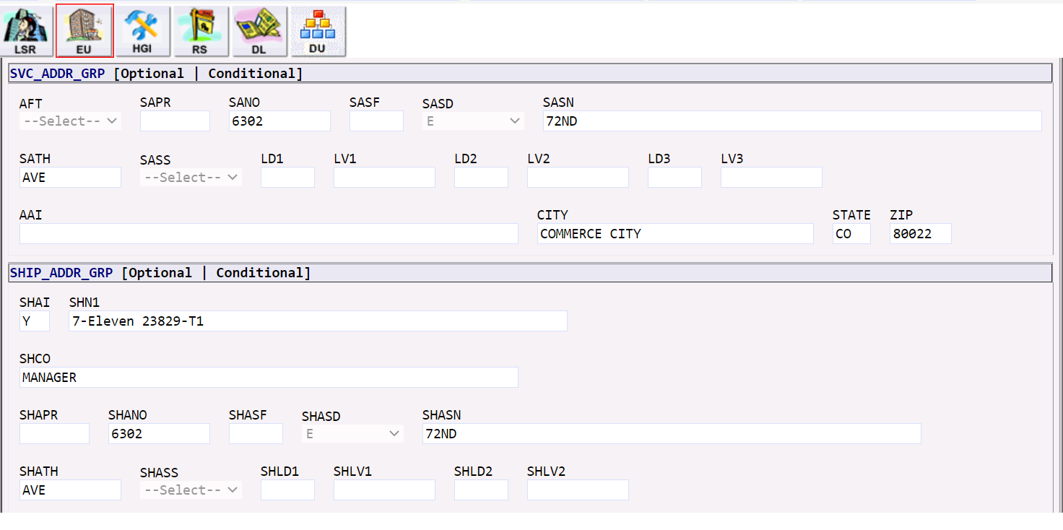

Addition of Account Number to the Virtual Front Office (VFO) Order List Excel output
Account Number (AN) has been added to the downloadable CSV formatted file.

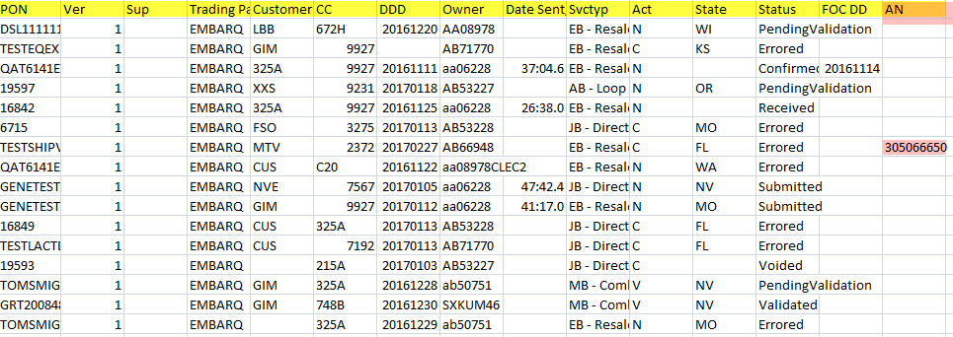

Prevent duplicate LSRs for same Working Telephone Number (WTN)
New functionality will identify duplicate LSRs for the same Working Telephone Number (WTN) and display an error message when this condition is identified for duplicate requests that have been received in the last 3 calendar days. Error messages will vary based on if the duplicate was created by the same or different CC.

Error Message for Duplicate LSR for Same CC and WTN

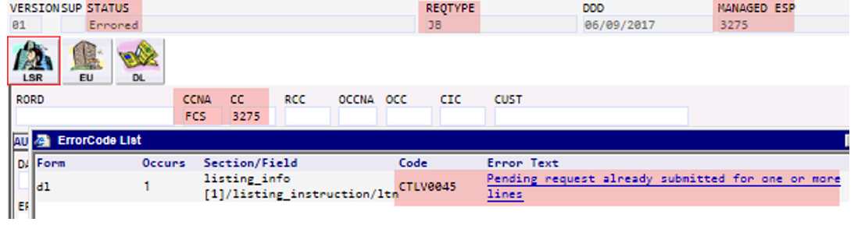

Error Message for Duplicate LSR for Different CC but same WTN

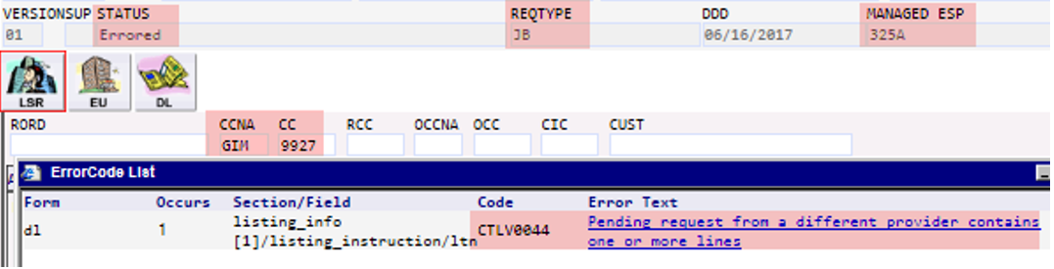

Versioning of Notices
The Exchange Carrier Version (EC VER) field entry is provided on all notices sent to the CLEC.
Each notice will increment separately as a new notice is created and sent for subsequent versions of that notice type. The EC VER will increment by one from the previous version.
LSR Response / Confirmation
EC VER #1
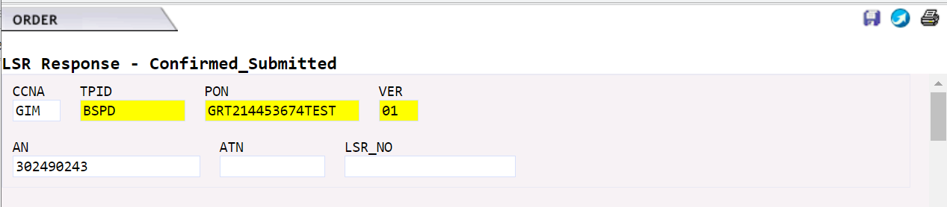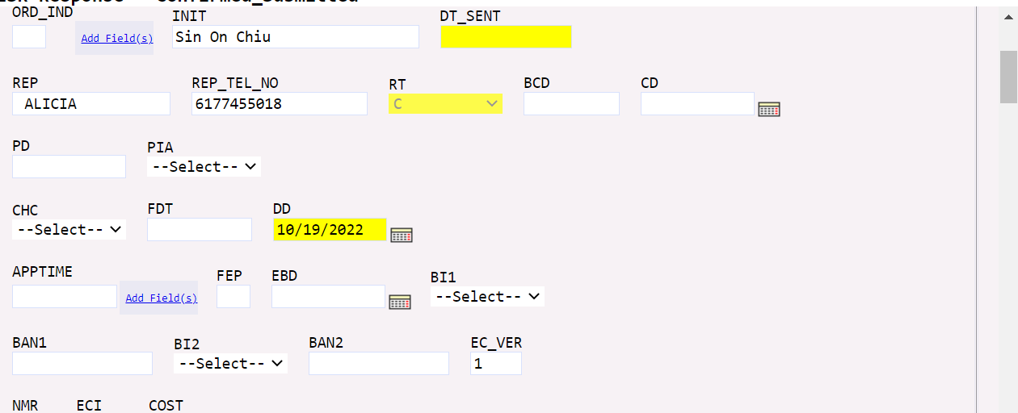

EC VE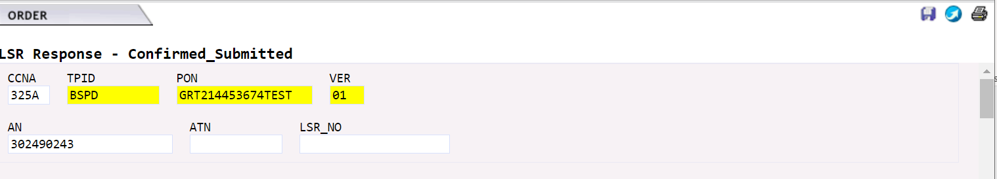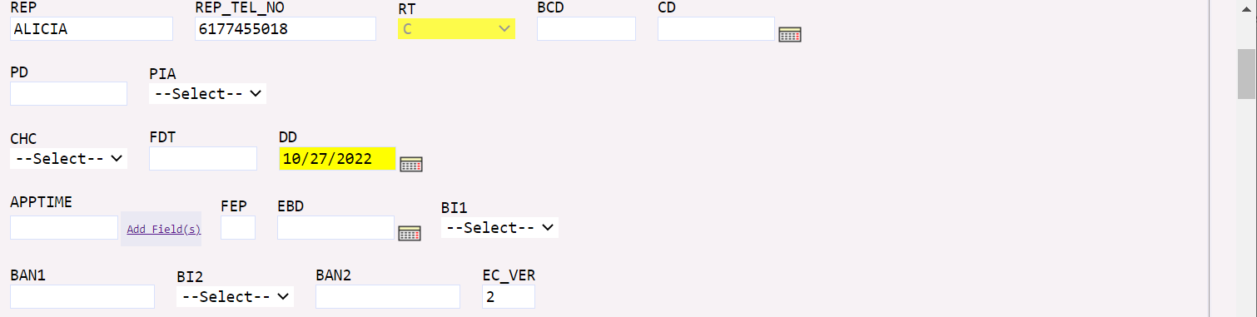
EC VER #3
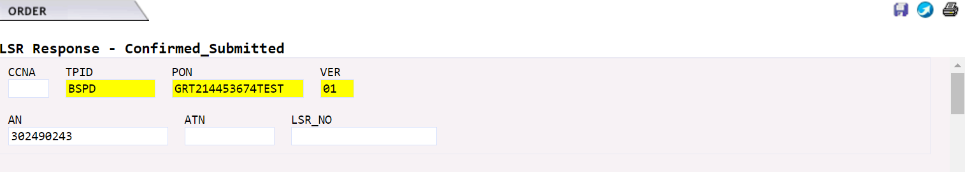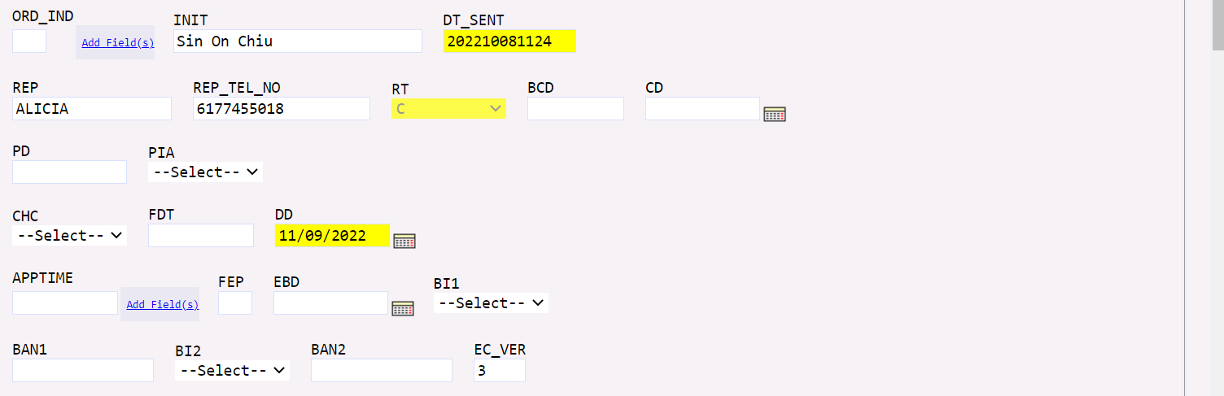

LSR Confirmation – Change to ORD field behavior
There is a change in existing functionality specific to LSR Confirmations. When an LSR results in multiple orders, the initial order will be placed in the ORD field, followed by a comma, and an entry of REMARKS2.

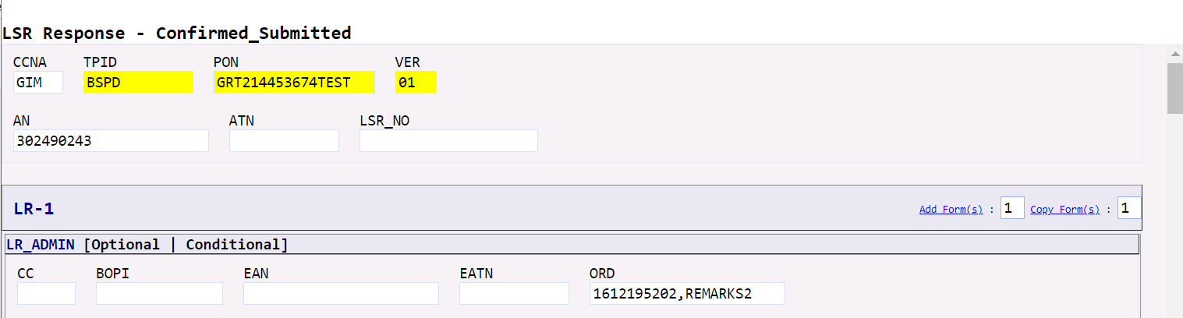

The entry of REMARKS2 directs you to see the balance of confirmed orders in the REMARKS2 field of the LSR Response. Multiple order numbers will be separated by commas.

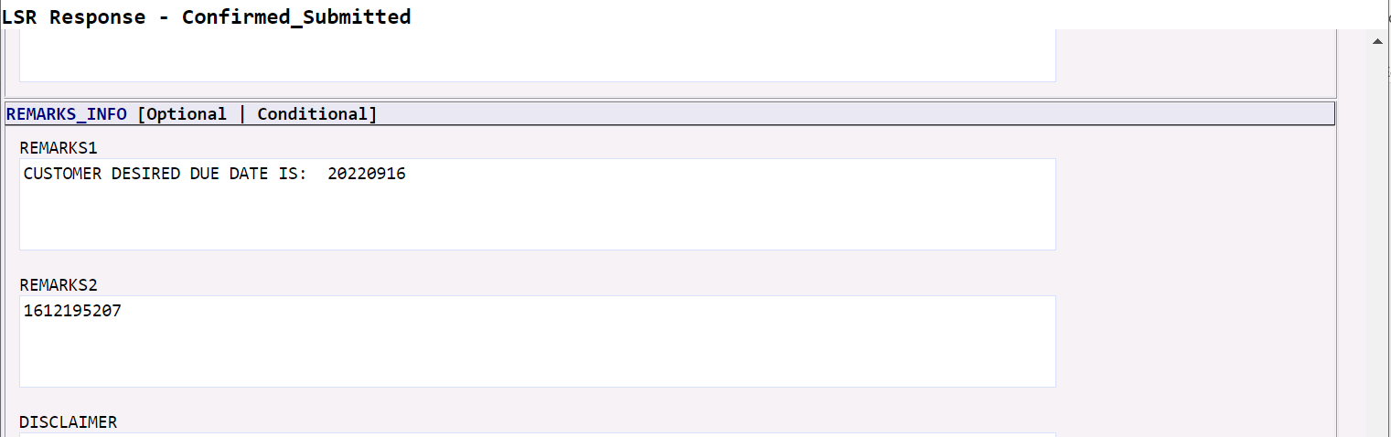

DLI Response Codes/Response Descriptions
You may receive multiple Response Codes and Response Descriptions for DLI (Directory Listing Inquiry) Transactions, which can be confusing. We are working to provide a better resolution in a future release.
For the February 2018 EASE LSR Release, the following behavior will be seen.

If the Listing Detail and Listing History are found:
- <RESP_STATUS_GRP>
<RESPC>27</RESPC>
<RESPD>Transaction Successful</RESPD>
<PRESPC>27</PRESPC>
<PRESPD> Owner: CLEC-XXXX</PRESPD>
</RESP_STATUS_GRP>

If the Listing Detail is not found:
- <RESP_STATUS_GRP>
<RESPC>18</RESPC>
<RESPD>Invalid Input or No Data Found</RESPD>
<PRESPC>18</PRESPC>
<PRESPD>No Historical Data is Found</PRESPD>
</RESP_STATUS_GRP>

If the Listing Detail is found and Listing History is not found:
- <RESP_STATUS_GRP>
<RESPC>27</RESPC>
<RESPD>Transaction Successful</RESPD>
<PRESPC>27</PRESPC>
<PRESPD> Owner: CLEC-XXXX</PRESPD>
</RESP_STATUS_GRP>
- <RESP_STATUS_GRP>
<RESPC>18</RESPC>
<RESPD>Invalid Input or No Data Found</RESPD>
<PRESPC>18</PRESPC>
<PRESPD>No Historical Data is Found</PRESPD>
</RESP_STATUS_GRP>

RESPC 18 – RESPC Invalid Input or No Data
PRESPC 27 – PRESPD Owner: CLEC-XXXX
PREPPC 18 – PRESPC No historical Data is found
This currently occurs due to three separate calls that are made to our backend systems for directory data:

- the first call is made to get the directory IDs
- then a second call is made to get the listing summary data
- and another call is made to get the listing history data

